Strategic Management
Introduction:
STRATEGY:
¬ Strategy comes from Greek word “ Strategos ” which means a plan to compete with enemy (in army ). ¬ Strategy means that a plan of action designed to achieve a long term overall goals.
¬ So, the Strategic management meant that making an action plan to achieve the organisational goals effectively and efficiently.
¬ We can say that it a game plan of any organisation to compete with competitors and stay for long time in market on top position.
¬ It is an integrated system, which focuses on all departments of an organisation (marketing, finance ,production ,R&D and so on ..) to achieve the organisational goals successfully.
Strategy - Meaning
Strategy is the determination of the long term goals and objectives of an enterprise and the adoption of the course of action and the allocation of resources necessary for carring out these goals. Strategy is management’s plan game plan for strengthening the organisation’s position, pleasing customers, and achieving performance targets.
Strategy – Definition
• Strategy is “a unified comprehensive and integrated plan designed to ensure that the basic objectives of the enterprise are achieved “-Glueck
• Strategy is “ a determination of the basic long term goals and objectives of an enterprise and the adoption of course of action and the allocation of resources necessary for carrying out these goals – Alfred Chandler 1
• Strategic management is “a stream of decisions and actions ,which leads to the development of an effective strategy to help achieve corporate objectives “-Glueck
Nature of Strategy:
• Strategy is a major course of action through which organisation relates itself to its environment. (External)
• Strategy is blend of internal &external factors. Face opportunities & threats provided by external factors, internal factors are matched with them.
• Strategic actions are different for different situations. Strategy is combination of actions to solve a certain problem to achieve a desirable end
• Strategy may involve contradictory actions simultaneously or with a gap of time like closing down some operations and expanding some at same time.
• Strategy is future oriented. New situations, which have not arisen in past will require revised Strategic Actions.
• Strategy requires some systems and norms for its efficient adoption in any organisation.
• Strategy provides overall framework for guiding enterprise thinking and action.
Types of strategy :
Strategy can be formulated on three different levels :
• Corporate level
• Business unit level
• Functional or departmental level
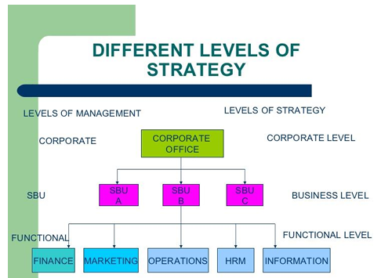
Business level:
Business level strategies are formulated for specific strategic business units and relate to a distinct product -maker area. It involves defining the competitive position of a strategic business unit. The business level strategy formulation is based upon the generic strategies of overall cost leadership, differentiation, and focus .
For example , your firm may choose overall cost leadership as a strategy to be pursued in its steel business , differentiation in its tea business , and focus in its automobile business. The business level strategies are decided upon by the heads of strategic business units and their teams in light of the specific nature of the industry in which they operate .
• Involves defining the competitive position of a strategic business unit .
• Decided upon by the heads of strategic business units and their teams .
Functional level:
Functional level strategies relate to the different functional areas which a strategic business unit has , such as marketing , production and operations , finance , and human resources . These strategies are formulated by the functional heads along with their teams and are aligned with the business level strategies. The strategies at the functional level involve setting up short – term functional objectives , the attainment of which will lead to the realization of the business level strategy .
For example, the marketing strategy for a tea business which is following the differentiation strategy may translate into launching and selling a wide variety of tea variants through company -owned retail outlets. This may result in the distribution objective of opening 25 retail outlets in a city : and producing 15 varieties of tea may be the objective for the production department . The realization of the functional strategies in the form of quantifiable and measurable objectives will result in the achievement of business level strategies as well .
• Formulated by the functional heads along with their teams .
• Involves setting up short -term functional objectives.
• Understand the three levels of strategy for an organisation
Corporate level :
Corporate level strategy defines the business areas in which your firm will operate. It deals with aligning the resource deployments across a diverse set of business areas, related or unrelated. Strategies formulation at this level involves integrating and managing the diverse businesses and realizing synergy at the corporate level. The top management team is responsible for formulating the corporate strategy. The corporate strategy reflects the path toward attaining the vision of your organisation .
For example , your firm may have four distinct lines of business operations , namely , automobiles, steel, tea , and telecom. The corporate level strategy will outline whether the organisation should compete in or withdraw from each of these lines of businesses , and in which business unit , investments should be increased , in line with the vision of your firm .
• Defines the business areas in which your firm will operate.
• Involves integrating and managing the diverse business and realizing synergy at the corporate level .
• Top management team is responsible.
STRATEGIC MANAGEMENT
DEFINITION:- The term ‘strategic Management’ is used synonymously with term ‘strategic planning’. The purpose of Strategic management is to exploit and create new and different opportunities for tomorrow
-----LIOYDL BYARS.
“Strategic Management is a strain of decisions and actions, which leads to the development of an effective strategy or strategies to help achieve corporate objectives.” --------GLUECK.
Evolution of Business Policy as discipline.
• Origin -1911- Harvard Business School – Integrated Course in Management aimed at providing general management capability.
• Hofer : Strategic Management – A Casebook in Policy and Planning : The Business Policy evolution has undergone four Paradigm Shifts. This transition is of overlapping nature.
- Development of subject of Business Policy has always followed the demands of real life business.
• 1930 -1960: Environment change : New Products Continuously changing market : Ford Foundation recommended report , by Gorden and Howell , suggested a “Capstone “ course of Business Policy which would give the students an opportunity to pull together what they have learned in the separate business fields and utilise this knowledge in the analysis of complex business problems .
• 1969: The course was made mandatory by American Assembly of Collegiate School of Business ( AACSB )
• 1990 :The course has become an integral part of management education curriculum.
Evolution of Business Policy has undergone four Paradigms
Paradigm One ;Ad -hoc Policy – making.
• 1900-1930 : Era of Mass Production – Maximising output , Normally a Single Product , Standardised and low cost product , catering to unique set of customers servicing limited geographical area -Informal control amnd co-ordination . The Strategic planning was centred on maximising output.
Paradigm Two – Integrated Policy Formulation .
• 1930-1940:Changes in Technology , Turbulence in Political environment , Emergence of new industries , Demand for novelty products even at higher costs , Product Differentiation , Market segmentation in increasingly competitive and changing markets . These all made investment decisions increasingly difficult. This was era of integrating all functional areas and framing policies to guide managerial actions.
Paradigm Three – The Concept of Strategy .
• 1940-1960 : Planned policy became irrelevant due to increasingly complex and accelerating changes . Firms had to anticipate environmental changes . A strategy needed to be formed with critical look at basic concept of Business and its relationship to the existing environment then .
Paradigm Four – The Strategic Management
• 1980 & onwards : The focus of Strategic Management is on the strategic process of business firms and responsibilities of general management.
- Everything outside the four walls is changing rapidly and this phenomenon is called as “ Discontinuity “by Mr. Peter Drucker. Past experiences are no guarantee as science and technology is moving faster. The future is no more extension of the past or the present.
• The world is substantially compressed and managing the External & Internal environment becomes crucial function.
• What to produce , where to market , which new business to enter , which one to quit and how to get internally stronger and resourceful are the new stakes.
• Strategic Planning required to be done to endow the enterprise with certain fundamental competencies/distinctive strengths which could take care of eventualities resulting from unexpected environmental changes.
The Indian Scenario:
However, the evolution of this fourth phase is still continuing and is yet not formed into a theory of how to manage an enterprise. But Strategic Management is a very important tool for and way of thinking to resolve strategic issues .
• IIMS and Administrative Staff College of India formed in early sixties were based on American Model. IIM -A is based on Harvard Model. The All India Council of technical Education (AICTE), The Association of Indian Management Schools (AIMS) has recommended a standard curriculum including “Business Policy and Strategic Management “as a compulsory course. Business policy is the preferred nomenclature but Strategic management is being progressively adapted.
Evolution of Strategic Management in India is divided in three periods .
Till 1980: Pre – liberalisation Stage:
• Strategic management of Government fringes.
• Entwining enterprise objectives into the national planning framework.
• Grabbing opportunities, high diversification, non- competitive scales, and weak technology.
• Secretive & one man Strategic Management Process.
Till 2000: Liberalisation Stage:
• ‘Foreign Complex ‘governed strategy.
Strategy of focus on rationalisation and operations improvement.
• Strategy of growth through acquisitions, internationalisation and product market expansion.
• Employing international consulting firms in Strategic Management.
2000-2010: Post Liberalisation Stage
• ‘Global maverick ‘mind-set & Acquire professional skill in Strategic Management and synergise entrepreneurial flair. • Portfolio rationalisation, entry into emerging sectors.
• Mobilise resources and ensure adequate growth through existing business.
• Demerge businesses as independent companies and improve market capabilities
• Development of Technology capabilities Decentralise organisations, develop institutionalised control mechanism.
CHARACTERISTICS OF STRATEGIC MANAGEMENT: Characteristics of strategic management include following;
- Systematic phenomenon
- Multi disciplinary
- Hierarchical
- Dynamic
- Multi dimensional
STRATEGY IS A SYSTEMATIC PHENOMENON:
• Strategy involves a series of action plans, no way contradictory to each other because a common theme runs across them.
• It is not merely a good idea; it is making that idea happen too
• Strategy is a unified, comprehensive and integrated plan of action.
IT IS MULTIDISCIPLINARY:
• Strategy involves marketing, finance, human resource and operations to formulate and implement strategy.
• Strategy takes a holistic view. It is multidisciplinary as a new strategy influences all the functional areas, i.e. marketing financial human resource and operations.
IT IS HIERARCHICAL:
• On the top come corporate strategies, then come business unit strategies, and finally functional strategies.
• Corporate strategies are decided by the top management, Business Unit level strategies by the top people of individual strategic business units, and the functional strategies are decided by the functional heads.
IT IS DYNAMIC:
• Strategy is to create a fit between the environment and the organization’s actions.
• As environment itself is subject to fast change, the strategy too has to be dynamic to move in accordance to the environment.
- Success of Microsoft appears to be very simple as far as software for personal computers are concerned, but Microsoft strategy required continuous decisions in a turbulent and dynamic environment to remain leader.
IT IS MULTIDIMENSIONAL:
• Strategy not only tells about vision and objectives, but also the way to achieve them.
• So, it implies that the organization should possess the resources and competencies appropriate for implementation of strategy as well as strong performance culture, with clear accountability and incentives linked to performance.
GUIDELINES FOR EFFECTIVE STRATEGIC MANAGEMENT:-
Following are the important guidelines for effective strategic Management;
¬ Strategic management should be a people process more than a paper process.
¬ It should be a learning process for all managers and employees
¬ Keep the strategic management process as simple and no routine as possible.
¬ Strategic management should vary assignments, team memberships, meeting formats, and even planning calendar.
¬ It should challenge the assumptions underlying the current corporate strategy.
¬ It should welcome bad news.
¬ An important guideline for effective strategic management is open mindedness. ¬ Do not purpose too many strategies at once.
Benefits of Strategic Management:
1. Strategic management is the process of formulating, implementing and evaluating strategies to achieve its organization objectives.
2. Organization acts proactively rather than reactive to any situation.
3. Communicates the mission, vision, objectives and policies to all the employees to understand the purpose of organization
4. Gathers information from external and internal environment assists in formulating strategies for the future success of an organization.
Importance of Strategic Management:
Strategic Management offers both financial & non financial benefit to an organisation as listed below
1. It allows identification, Prioritization &exploitation of opportunities
2. Provides objective view of management problems
3. Framework for Improved co-ordination.
4. It minimizes the effect of adverse conditions
5. It allows major decisions to better support established objectives
6. It allows more efficient allocation of time.
7. It allows fewer resources and less time to be devoted
8. It creates a framework for internal communication
9. It helps to integrate the behaviour of individuals
10. It provides basis for the clarification of individual responsibility.
11. It encourages to forward thinking
12. It provides a co operative , integrated approach to tackling problems.
13. It encourages a favourable attitude
14. It gives a degree of discipline.
SRATEGIC MANAGEMENT AS PROCESS:
• A process is the flow of information through interrelated stages of analysis toward the achievement of an aim.
• Strategic management as a process has several important implications;
- First, a change in any component will affect several or all of the components. For e.g.; forces in external environment may influence the nature of a company’s mission and vice versa.
- Second implication of viewing of strategic management as a process is that strategy formulation and implementation are sequential.
- Third is necessity of feedback (analysis of post implementation results) from institutionalization, review and evaluation to the early stages of the process. iv. Fourth, the need to regard strategic management as a dynamic system.
• As a process, strategic management includes the following steps;
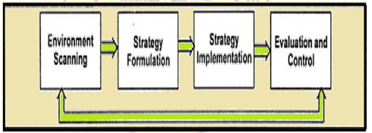
ENVIRONMENTAL SCANNING:-
• Environmental scanning is the monitoring, evaluating, and dissemination of information from the internal and external environments.
• Its purpose is to identify strategic factors those external and internal elements will determine the future of the corporation.
• The simplest way to conduct environmental scanning is through SWOT Analysis.
• SWOT is an acronym of strength, weakness, opportunities, and threats for a specific company.
External Environment:-
• External environment consists of opportunities and threats that are outside the organization.
• External factors are not typically within the control of top management.
Example: - Technological factors, legal factors, competitors, social & culture factors and so on.

Internal Environment:-
• Internal environment of a corporation consists of variables (strengths and weakness) that are within the organization.
• Top management has control on all these factors.
Example:- company’s structure, culture and resources.
There are some drawbacks of environmental analysis:
- Environmental analysis does not predict the future, nor does it eliminate uncertainty for any organization.
- Environmental analysis is not a sufficient guarantor of organizational effectiveness.
- The potential of environmental analysis is often not realized because of how it is practiced.
STRATEGY FORMULATION:
• Strategy formulation means formulating of long term organizational plans that would assist in carrying –out organization activities in best possible way.
• Strategy formulation is essential for optimum functioning of the organization.
• Strategy formulation involves developing corporate vision, mission, setting objectives, formulating strategies which are as follows;
Vision of the Organization:-
• An organizations vision statement can be explained as a position that organization aspires to achieve in the future.
• A vision statement is developed by top management which may include CEO, President, managing director, chairman etc.,
Mission of the Organization:-
• A mission statement descried the reason for the existence of the organization.
• It specific the organizational culture and values and also sets guiding points for carrying out business activities of organization.
Objectives:-
• Organizational plans are usually long term and the craft long-term objectives.
• Objectives are the results that one expects out of the business activities.
• The objectives envelope areas like organization’s profitably, competitive position, public image, ROI (return on investment), productivity, employees growth etc.,
Strategies:-
• A strategy of an organization is a detailed plan which helps the organization in realizing its mission and objectives.
• Strategies are formulated for achieving competitive advantage.
Policies:-
• Policies refer to set of instructions that are used for strategy formulating and strategy implementation.
• Policies focus on achieving corporate goals by ensuring optimum allocation of resources.
STRATEGY IMPLEMENTATION:-
• After formulating a strategy, next step is to ensure effective implantation of formulated strategies.
• Strategies are implemented with the help of;
a. Programmers (actions or steps needed to implement a single use plan and they help in putting strategies into action.
b. Budgets:- (declaration of organization’s programmed in monetary terms)
c. Procedures:- (step-by-step explanation of order in which a task is to be carried –out) d. Without successful implementation, as well devised strategy is of no use.
EVALUATION AND CONTROL:-
• Evaluation and control is final step in the process of strategic management.
• After implementing a strategy, it must be evaluated on a regular basis.
• Successful evaluation of strategy is based on suitable and prompt feedback.
• Control should be imposed that it produces intended remedial action.
• The amount of control that needs to be imposed is based on different between actual and expected results.
MEANING OF VISION:-
• A vision statement can be referred as the statement defining company’s long-term goals.
• A vision statement can exceed from one line to a few paragraphs highlights what the organization wants to achieve in future.
• Vision statement is common, mutual and for every employee in the organization.
• Vision statement is simple, unique, and competitive in nature.
• A good vision statement encourages the organization to take risks and to pursue innovation ideas to stay competitive in market.
DEVELOPING A STRATEGIC VISION:- For developing a vision statement, following steps are included;
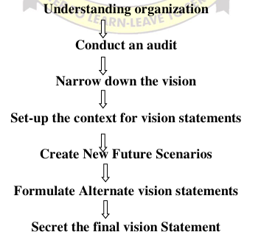
UNDERSTANDING THE ORGANIZATION:-
• The foremost step of formulating a vision statement to understand the organization.
• To understand the organization in a better way.
The following details should be considered:
- Nature of the industry.
b) Mission and purpose of the organization
c) Kind of value it is providing to the society.
d) Structure of the organization.
CONDUCT AN AUDIT:-
• Once the understanding of organization has been achieved, the next step is to conduct as audit to access the current position of the organization.
Following aspects are to be analyzed at these stages;
a) Current direction of the organization.
b) Organizational structure.
c) Organizational activities.
d) Compensation and remuneration plans.
NARROW DOWN THE VISION:-
• After conducting the audit, the next thing to do is to narrow down the vision statement
• Narrowing down here implies considering the factors that are needed to form a vision statement.
SET-UP THE CONTENT FOR VISION STATEMENT:-
• In this step, the strategic leaders should anticipate the future aspects of the organization.
• Some of the aspects to be considered are:-
a) Anticipation and categorization of future developments which may affect the vision.
b) Anticipate the probability of fulfilling the expectations.
c) Assigning the probability of occurrence to each expectation.
CREATE NEW FUTURE SCENARIOS:-
• As soon as the expectations are anticipated and their effect and probability fulfillment are understood, next step creation of new scenarios should considered.
• This is to associate those expectations to form a new scenario which involves a variety of possibilities in future anticipated by leaders.
FORMULATED ALTERNATIVE VISION STATEMENTS:-
• Here, the possible future alternatives are discovered and decided.
• Alternative vision statements for each direction are formulated.
SELECT THE FINAL VISION STATEMENT:-
• This is the final stage where the strategic leaders would select the best among the alternative vision statements.
• For selecting best one, it is necessary to closely analysis the vision Statements.
Following are some of the examples of vision statement;
• BHEL:- “ A world class innovative, competitive and Profitable engineering enterprise providing total business solutions
• WIPRO:-“Be among the 10 most admired Indian corporations.”
• COLGATE-PALMOLIVE: - “to be the company of first choice in oral and personal hygiene by continuously caring for consumers and partners.”
• MICROSOFT: “Empower every person and every organization on the planet to achieve more”.
• NIKE: “Bring inspiration and innovation to every athlete in the world.
• APPLE: “To produce high-quality, low cost, easy to use products that incorporate high technology for the individual”.
• SONY: “To be a company that inspires and fulfills your curiosity”.
BASIC ELEMENTS OF A VISION STATEMENT:-
Vision is simply a combination of 3 basis elements;
• An organization’s fundamental reason for existence beyond just making money.
• Its timeless, unchanging core values. The core values define the enduring character of an organization that remains unchanged as it experiences changes in technology, competition, management styles etc., • Huge but, achievable aspirations for its future.
COMPONENTS OF VISION STATEMENTS:
• It is written in the present, not future tense. They describe what we will feel, hear, think, say and do as if we had reached our vision now.
• It is summarized with a powerful phrase. That phrase forms the first paragraph of the vision statement. The powerful phrase is repeated in whatever communication mediums you have to trigger memory of the longer statement. It is not a brand strap-line.
• It describes an outcome, the best outcome we can achieve. It does not confuse vision with the business goal and objectives for a particular period of time. A vision statement, therefore, does not provide numeric measures of success.
• It evokes emotion. It is obviously and unashamedly passionate. However, it separates the hard aspect of vision in what we see, hear and do from the soft aspect of vision in what we think and feel.
• It helps build a picture, the same picture, in people’s minds.
MISSION:
MEANING AND DEFINITION OF MISSION STATEMENT:-
Organizations are founded for a purpose. Although the purpose may change over time, it is essential that stakeholders understand the reason for the organization’s existence that is the organization’s mission. The mission is an enduring statement of purpose that distinguishers one business from other similar firms. A mission statement reveals the long-term vision of an organization in terms of;
- What it wants to be,
- Where exactly it wants to go,
- Whom it wants to serve
The obvious purpose of a mission statement is to give a public announcement to insiders and outsiders about what the firm’s stands for, what makes the firm different. The mission statement is generally expressed in a board manner and it is unlikely that it can be ever achieved completely.
DEFINITION:- “The mission reflects the essential purpose of the organization, concerning particularly why it is in existence, the nature of business it is in, and the customers it seeks to serve and satisfy.”
CHARACTERISTICS OF A MISSION STATEMENT:
- Clarity
- Broad and enduring
- Realistic
- Specific
- Identity and image
CLARITY:
• The mission statement should be clear enough to lead to action.
• The corporate dream must be presented in crystal-clear manner preferably in a positive tone. For example: SBI – “with you, all the way”
BROAD AND ENDURING:-
• The mission statement is a grand design of the firm’s future. So, it should be in a board manner.
• However, a mission statement should not be so narrow as to restrict the firm’s operations nor should it be too general to make itself meaningless.
• To make things clear, mission statements come in two forms ; primary mission (a general category of business to be engaged in and secondary mission defining everything more specifically Telco for example is in the transportation business primary business.
REALISTIC:
• Missions should be register and achievable.
• Air India would be deluding believing that is not true itself if it adopted the mission to become the world’s favorite’s airline
SPECIFIC:
•Mission should be specific.
• Mission must define the competitive scope within which the company will operate that is the range of industries in which a company will operate industrial goods consumer goods services
. • Range of products and applications the company will supply.
• Range of products and applications the company will supply.
• Range of regions countries in which a company will operate.
• Company’s core competencies.
Example: Mc Donald’s could probably enter the solar energy business but that would not take advantage of its core competencies providing low cost food and fast service to large number of customers.
IDENTITY AND IMAGE:
• The mission sets a firm apart from other firms of its style.
• Through the mission statement the firm wants to maintain its distinct image and character in terms of excellent quality and service latest technology a unique produced offerings etc.
For example;
a) An Asian paint stresses leadership though excellent.
b) MTNL presents it as the lifeline of destine and Mumbai. c) Bajaj Auto offers value for money for years.
EXAMPLES OF MISSION STATEMENTS:

Cadbury India :
To attain leadership position in the confectionary market and achieve a strong national presence in the food drinks sector.
Coca Cola: To refresh the world. To inspire moments of optimism and happiness. To create value and make a difference.
P&G: We will provide branded products and services of superior quality and value that improve the lives of the world’s consumers.
Wal-Mart: Helps people around the world save money and live better — anytime and anywhere — in retail stores, online and through their mobile devices.
BENEFITS OF MISSION:
- Provides direction to organization
- Promotes functions and features of org
- Motivates employees
- Sets core values
MOTIVATES EMPLOYEES:
• Mission statements motivate employees of the organization to enhance their skills not only personal gains and also for achieving the common organizational goals.
• Mission statement helps to create an environment of shared values among employees and guide them in their regular activities.
SETS CORE VALUES:
• A mission statement sets core values within the organization.
• It identifies the direction in which the organization wishes to proceed and also determines the ways in which the objective is to be achieved.
• If at times the organization loses its track and engages in some unethical activates the mission statement helps in bringing it back on the track.
DESCRIBE ORGANIZATIONAL GOALS:
• A mission statement defines the goals that are to be achieved by the organization.
• It portrays a clear picture about the business it deals in and the fundamental idea about the organization.
• Whatever its form, a mission statement should give readers a clear idea about what a business does.
IMPROVES ORGANIZATION PERFORMANCE:
• Mission statement helps the organization to improve its financial position by balancing and enhancing the overall organizational performance.
If the organization mission statement is achievable and feasible it motivated the employs to stretch their abilities to outperform themselves.
COMPONENTS OF MISSION STATEMENTS:
- Products and services
- Technology
- Target market
- Policy for employee
- Public images
PRODUCTS OR SERVICES:
• A mission statement should indicate the products or survives the organization deals in. For example: The mission statement of Assurant is to be the premier provider of targeted specialized insurance products and related services in North America and selected other markets.
TECHNOLOGY:
• A mission statement should describe about the technology being implemented for achieving the organizational goals.
• This helps the organization in acquiring better technology vendors.
TARGET MARKET:-
• An organization should indicate the type of market it serves in a mission statement. For example: while the mission of a cosmetic company may serve only for women a company producing shaving creams would serve only for men.
POLICY FOR EMPLOYEES:
• A mission statement should indicate its policies regarding its employees so that they realize their importance in the organization.
PUBLIC IMAGE:
By formulating a mission statement, strategic leaders are able to convey the basic features and function of the organization which helps in creating appositive public images.
OBJECTIVES:
• An objective indicates the result that the organizations expect to achieve in the long run.
• It is an end result the end point something the youth aim for and try to reach.
• It is a desired result towards which behavior is directed in an organization.
• The organization may or may not reach the desired state but the chances of doing so are greater if the objectives are farmed and understood properly. Objectives are the product of specific concrete thinking.
Classification of Objectives:
1) Primary objectives
2) Secondary Objectives
3) Short term objectives
4) Medium term objectives
5) Long-term objectives
6) Financial Objectives
7 Non-Financial Objectives
PRIMARY OBJECTIVES:-
• Primary objectives are those which are concerned with fulfilling the needs of primary stakeholders and consumers.
• They are long term goals of the organization hence these also called as strategic objectives.
• Primary objectives of an origination can be surviving in competition maximizing profit increasing market share etc. Example: The primary purpose of a business is to maximize profits for its owners or stakeholders while maintaining corporate social responsibility
SECONDARY OBJECTIVES:-
• Secondary objectives also called as tactical objectives.
• Secondary objectives are set to perform daily operation smoothly.
• These objectives address the issue of wages, composition incentives, recognition etc.
SHORT TERM OBJECTIVES:
• Short term objectives are set to achieve short term targets.
• These are set for up to one year or one financial year.
• For an organization short term objective can be used for increasing sales reducing the layout turnover etc.
MEDIUM- TERM OBJECTIVE:
• Medium term objectives are set for the period of the months to five years.
• Medium term objectives convert into short term objectives with the passage of time.
For e.g. introducing variants of existing product modification in existing rotational structure etc.
LONG TERM OBJECTIVE:
• Long term objectives are broad and inspiring in nature.
• The duration of long term objective in more than five years.
For e.g. diversifying the business acquiring or merging a new business global expansion of business etc
FINANCIAL OBJECTIVES:
• Financial objectives are associated with monetary benefits.
• Financial objectives of an origination can be maximizing sales increase revenue by 20 reducing product cost etc.
• These objectives may be short term as well as medium term.
NON FINANCIAL OBJECTIVES:
• Non financial objective are not associated with monetary benefits.
• These objectives a help the organization to evaluate the intangible aspects of a business such as stability, health, long term success, culture, values etc.
ROLE OF OBJECTIVES:- Objectives serve the following function; Role of Objectives----
- Direction
- Benchmark for Success
- Basis for Managerial Functions.
- Basis for Organ existence
- Basis for Various plans
DIRECTION:
• Objectives provide guidelines for origination efforts they keep attention focused on common purpose. • Every activity is directed toward the objectives every individual contributes to meet the goals.
BENCHMARK FOR SUCCESS:
• Objectives eve as performance standards against width actual performance be checked.
• They provide a bench mark for assessment.
• Objectives help in the control of human effort in an organization.
Motivation:
• Objectives of one level are a source of inspiration and motivation to achieve goals at higher levels.
• Workers strive hard to achieve innovation and challenging goals rational and attainable objectives motivate employee to work hard.
Basis for Managerial Functions:-
• Objectives provide basis for all managerial functions
. • Planning, organizing, staffing, directing and controlling are directed towards organizational objective. • Unless organizational objectives are clearly identified, managerial functions will not be effectively carried out.
Basis for Organizational Existence:-
• Objectives provide foundation or legitimacy to business organization.
• An organization will not come into existence if it has no objective to achieve.
• Objectives enable the organization to make its profile (identify its strengths and weakness) and relate it with environmental profile (opportunities and threats).
MEANING OF POLICIES:
• The term policy is derived from the Greek word “Politician” relating to policy that is ‘citizen’ and Latin work “polities” meaning ‘polished’, that is ‘to say clear’.
• A policy is a deliberate system of principles to guide decisions and achieve rational outcomes. A policy is a statement of intent, and is implemented as a procedure or protocol.
• Policies are generally adopted by a governance body within an organization. Policies can assist in both subjective and objective decision making.
DEFINITION:
• The term “Policy” is defined by KOONTZ and O ‘DONNEL as “policies are general statements or understandings which guide mangers thinking in decision making”.
• George R.TERRY defined “policy is a verbal written or implied overall guide setting up boundaries that supply the general limits and direction in which managerial action will take place”.
CHARACTERISTICS OF POLICIES:
Although different businesses may have different policies, any business policy has the same seven features. A business policy must be specific, clear, uniform, appropriate, simple, inclusive and stable.
- SPECIFIC:
• If a policy is not specific, implementation becomes inconsistent and unreliable.
• For example, "Employees may not park in the guest parking lot."
- CLEAR:
• A business policy has no ambiguity. It is written in easy-to-understand language.
• For example, "Immediate release of employment is the result of company drivers having two points on their driving record."
UNIFORM:
• The policy should be a standard that everyone can follow from the top management to the plant workers.
• For example, "Anyone entering the construction site must have a protective hat, shoes and glasses on at all times."
- APPROPRIATE:
• Business policies should be relevant to organizational goals and needs.
For example, "Discrimination and sexual harassment accusations are investigated with disciplinary action applicable based on investigation findings."
- SIMPLE:
• Policy must be understood by all that it applies to within the business.
For example, "No smoking within 100 feet of welding operations designated by the painted yellow floor lines."
TYPE OF POLICIES:
A. On the Basis of Source:
(i) Originated Policy.
(ii) Appealed Policy.
(iii) Implied Policy.
(iv) Externally imposed policy.
(i)ORIGINATED POLICY:
• By originated policy they refer to policy which originates from the top management itself.
• These policies are aimed at guiding the managers and their subordinates in their operations.
• They flow basically from the organization’s objectives as defined by top management.
(ii)APPEALED POLICY:
• It is meant decisions given in case of appeals in exceptional cases up to management hierarchy.
• In case of doubts, an executive refers to higher authority on how he should handle the matter.
(iii)IMPLIED POLICY:
• Implied policy is meant policies which emanate from conduct.
• It also originates where existing policies are not enforced.
Iv EXTERNALLY IMPOSED POLICY:
• Policies may be imposed externally that is from outside the organization on such as by Government control or regulation, trade associations and trade union etc.
On the Basis of different Levels:
- Basic Policies.
- General policies.
- Departmental Policies.

- BASIC POLICIES:
• Policies which are followed by top management level are called as basic policies.
For example, the branches will be opened in different place where the sales exceed Rs.5lakhs. ii. GENERAL POLICIES:
• These policies affect the middle level management and more specific than basic policies. Example: Payment will be provided for overtime work only if it is allowed by the management.
- DEPARTMENT POLICIES: These policies are highly specific and applicable to the lower levels of management.
Example: Tea will be provided free for workers in night shifts.
- On the Basis of Managerial Functions: Policies arise from decision pertaining to fundamental managerial functions are called managerial policies.
These include the following policies:
- Planning policies.
- II. Organization policies.
- Motivation and control policies.
- PLANNING POLICIES:
Planning policies involve the future course of action. Mere policies are formulated as to achieve the targets regarding the future. Planning policies may formulate for whole organization or for divisional departments.
- ORGANIZATION POLICIES: These policies are highly specific to organizational goals and objectives.
- MOTIVATION AND CONTROL POLICIES:
Here policies are formulated to motivate people and control the activities, which lead to achieve the organizational objectives with the fullest satisfaction of employees.
CORE COMPETENCY:
Core competencies make or break innovation. While everyone can have a business idea, not all of them have the feasibility to thrive in the market. Those that do, have to be relevant, useful and adaptive. Simply put, the activities, knowledge and internal organizational structure within the firm sets you apart from your competitors.
DEFINITION: “Core competence is the collective learning in an organization especially how to coordinate diverse production skills and integrate multiple streams of technologies”.
CONCEPT OF CORE COMPETENCIES:
• Core competencies, which are sometimes called core capabilities or distinctive competencies help, create a sustained competitive advantage for organizations.
• A core competency is a skill at which an individual is especially proficient, or a set of activities that an organization performs better than other functions – whether more efficiently, at lower cost or at higher quality
Examples of Core Competencies:
• Analytical Thinking. This refers to your ability to apply logic to solve problems and to get the job done.
• Client Service.
•Creative Thinking.
• Forward Thinking.
• Conceptual Thinking.
• Conflict Resolution
Core competencies point you to resources with different specializations which can lower your transactional expenses. This in turn, gives them the freedom to develop new products or modify existing services as per their skills and capabilities to suit market needs.
Here, heterogeneity plays a pivotal role because if every organization had the same set of skills and capabilities, they wouldn’t be able to make decisions that strategically differ.
Toyota is one such example of an automobile giant that utilized its resources and capabilities to raise its product quality. It pioneered a lean production system that proved difficult to replicate. Further, It introduced the concept of just-in-time manufacturing which reduced its setup time. The lowered pricing model and lasting efficiency rapidly gained widespread popularity which helped Toyota retain consumer loyalty. Thus, it was able to still reap profits while competing against Mercedes and BMW models.
Questions would pop up in your mind:
1. Why would customers buy your products or services?
2. How are you different from your competitors?
3. How can you bundle your resources in order to gain a market advantage?
4. What are the key success factors that stamp out the competition?
Core competencies stem from the effective procurement and usage of your resources and capabilities bundled together. Capabilities drive your firm’s ability to adapt its core competencies over time.
If your future plans include expanding your presence, you need to evaluate your internal environment beforehand so as to maximize the value added to the customer chain.
Characteristics of Core competencies:
The first step of your competitive advantage starts with evaluating enterprise-wide internal strengths and weaknesses. It lets you filter out those resources and capabilities that fit like jigsaw pieces to give you a competitive advantage.
Accessibility to different markets:
With changing market scenario the organization should offer value in several markets. The organization should not depend on a single market but should expand its business in different markets as per changing market conditions. This can be done successfully with core competencies.
Value Your resources use their knowledge to create value. Besides transforming inputs to outputs, value-addition also occurs when your resources successfully exploit profitable ventures or bring down external costs . A competitive advantage is based on the scope of knowledge integration internally. By widening this scope, you’ll have on board a wide variety of relevant and useful skills that complement your resources’ experience. The more experienced your resource pool, the smarter their strategy is at embracing newer information. Which is why investing in training, workshops and certifications is a worthwhile cause. These measures can help your resources diversify their professional range which gives you a competitive advantage, especially against new entrants who are building up on their expertise.
Rarity While resources devise and implement strategies, capabilities let you take full advantage of your resources. Immobilizing them may seem like a step backwards. But when you combine it with the heterogeneity that we mentioned earlier, both resources and capabilities acquire rarity. This ensures that your competitive advantage can’t be replicated neither easily nor quickly.
Imitability A subset of rarity, if your resources and capabilities can’t be substituted or reproduced elsewhere, they’re said to possess lower imitability. Big decisions don’t offer you a competitive advantage because other firms would hear of it through public announcements.
But the same can’t be said for the cumulative effect of small decisions taken by your resources. From making your website friendly to disabled users to adopting a new methodology, smaller decisions can prolong your competitive advantage. The cost to mimic these capabilities and resources should be higher than the compensation offered. This makes it hard for firms to entice your best people away from your firm, immobilizing their capabilities.
Non-Substitutable: If an organization wants its core competencies to become competitive advantages the competencies should be non substitutable.
Example, for a customer core agency a core competence may be to provide distinctive customer service. This core competence cannot be substituted with any other benefit.
Organization Control mechanisms such as formal reporting structures, compensation packages and a collaborative environment tie these 3 points together, thus helping you capture the actual value they bring in.

IMPORTANCE OF CORE COMPETENCIES:
- Strategic recruitment
- Compensation decisions
- People and organization development
- Coaching and mentoring for performance
- New employee orientation

STRATEGIC RECRUITMENT:
• Identifying core competencies create top down view to recruiting in which one can begin to plan for the skills needed to grow the organization.
• Assessing what the organization needs from a strategic view is the driving force to create strategic organization wide recruiting process.
COMPENSATION DECISIONS:
Using competencies to achieve effective job performance will be linked to employee compensation decisions.
PEOPLE AND ORAGANIZATION DEVELOPMENT:
Training can be based on developing core competencies needed to meet the current and future needs of the organization.
COACHING AND MENTORING FOR PERFORMANCE:
• Performance evaluation no longer is tasks lists with a grade.
• Evaluation can take the form of behavior development tool.
• The focus is not only upon work objectives but also upon the competencies that employee need to achieve professional success.
NEW EMPLOYEE ORIENTATION:
• From day one the new employee will be immersed in a culture that drives all employees towards achieving strategic objectives.
• Employees will enter the organization with a understanding of goals they need to accomplish.

Examples of Core Competencies
Here are three top examples of companies that have achieved continued success by focusing on their core competencies:
McDonald’s
Apple
Wal-Mart
The ability to standardise food service and delivery operations are McDonald’s strongest core capability. McDonald’s offers the same taste and appearance, regardless of location or point of sale, taking into consideration local preferences and exceptions. Customers trust the brand because they always know what they’re getting when they order a Big Mac or Chicken McNuggets. McDonald’s success is still driven by this conviction.
Apple, with its iPhone, iMac, and iPad, has a unique capacity to design and manufacture electronic gadgets that fulfill the aesthetic and physical needs of consumers. Each device has a pleasing visual aesthetic and tactile appeal, which has helped Apple become the most valuable corporation in the world with its present market value.
Wal-Mart has purchasing power unmatched by even its closest competitors. The company’s extensive supply chain activities enable it to purchase things in bulk at low prices, and then attract and retain more customers with lower pricing than competitors.

Environmental Scanning Meaning and Definition
The process of collecting, evaluating, and delivering information for a strategic purpose is defined as environmental scanning. The process of environmental scanning requires both accurate and personalised data on the business environment in which the organisation is operating or considering entering.

Environmental Scanning Example
- Example 1: A retail business uses environmental scanning to adapt to changing market trends. Internally, they assess employee skills and invest in IT upgrades for better efficiency. Externally, they monitor consumer preferences, regulatory updates, and competitor strategies. This helps them launch eco-friendly products and improve operations to stay competitive.
- Example 2: A tech company conducts environmental scanning to innovate and stay ahead. Internally, they evaluate their R&D capabilities and upgrade their technological resources. Externally, they analyse industry trends, emerging technologies, and competitors' product launches. This enables them to develop a cutting-edge product that meets market demands.

Kinds of environmental scanning

1. Continuous Scanning
Continuous scanning involves regularly monitoring the environment to identify trends, changes, or threats as they occur. It is an ongoing process that provides real-time insights, helping organisations adapt quickly to evolving circumstances.

2. Periodic Scanning
Periodic scanning is conducted at set intervals, such as quarterly or annually. This approach allows organisations to analyse environmental changes and trends at specific times, making it suitable for long-term planning and strategic reviews.

3. Ad-Hoc Scanning
Ad-hoc scanning occurs as needed, typically in response to a specific issue or challenge. Organisations use this type of scanning to address unexpected situations or opportunities, focusing on immediate decision-making.

4. Strategic Scanning
Strategic scanning focuses on long-term goals and objectives. It involves analysing trends and factors that could influence an organisation's future, helping to align strategies with anticipated environmental shifts.

What are the Characteristics of Environmental Scanning?
The characteristics of environmental scanning are as follows:

- Continuous Process- The analysis of the environment is a continuous process rather than being sporadic. The rapidly changing environment has to be captured continuously to be on track.
- Exploratory Process- Scanning is an exploratory process that keeps monitoring the environment to bring out the possibilities and unknown dimensions of the future. It stresses the fact that “What could happen” and not ”What will happen”.
- Dynamic Process- Environmental scanning is not static. It is a dynamic process and depends on changing situations.
- Holistic View- Environmental Scanning focuses on the complete view of the environment rather than viewing it partially.

Factors of Environmental Scanning

1. Internal Factors of Environmental Scanning:
Internal factors are elements within the organisation that directly impact its performance and operations. These include resources such as human capital, financial assets, and technological infrastructure. Changes in these internal factors can significantly influence the organisation's overall functioning and success.

2. External Factors of Environmental Scanning:
External factors refer to elements outside the organisation that affect its management and operations. Despite being outside the organisation’s control, these factors have a substantial impact on decision-making and strategy. External factors are further divided into two categories:

- Macro-Environmental Factors: These encompass broader influences such as legal, political, social, cultural, demographic, and technological aspects.
- Micro-Environmental Factors: These include more immediate external elements like suppliers, customers, competitors, markets, and other organisations.

Components of Environmental Scanning
- Internal Environmental Components- The components that lie within the organization are internal components and changes in these affect the general performance of the organization. Human resources, capital resources and technological resources are some of the internal environmental components.
- External Environmental Components: The components that fall outside the business organization are called external environmental components. Although the components lie outside the organization, they still affect the organizational activities. The external components can be divided into micro environmental components, and macro environmental components.

- Micro environmental components include competitors, consumers, markets, suppliers, organizations, etc.
- Macro environmental components include political, legal, economical, cultural, demographic, and technological factors.

Types of Environmental Scanning:
Here are some commonly used Techniques of Environmental Scanning:
- SWOT Analysis- SWOT analysis is an acronym for Strengths, Weaknesses, opportunities and threats analysis of the environment. Strengths and weaknesses are considered as internal factors whereas opportunities and threats are external factors. These factors determine the course of action to ensure the growth of the business.
- PEST Analysis- PEST stands for Political, economic, social, and technological analysis of the environment. It deals with the external macro-environment.
- ETOP- ETOP stands for the Environmental Threat Opportunity Profile. It helps an organization to analyze the impact of the environment based on threats and opportunities.
- QUEST- QUEST stands for the Quick Environmental Scanning Technique. This technique is designed to analyze the environment quickly and inexpensively so that businesses can focus on critical issues that have to be addressed in a short span.
TECHNIQUES/METHODS OF ENVIRONMENTAL SCANNING:
There are different techniques/methods of environmental scanning. They are discussed below:
- Executive opinion method:
• It is also called executive judgment method.
• Under this environment is forecasted on the basis of opinion and views of top executives.
• A panel is formed consisting of these executives.
- Expert opinion method:
• Under this, environment forecasting is based an opinion of outside experts or specialist.
• The experts have better knowledge about market conditions and customer taste and preferences. • This method is similar to executive opinion method. However, it uses external experts.
- Delphi method:
• This method is extension of expert opinion method.
• It involves forming a panel of experts and questioning each member of the panel about the future environmental trend.
• Later, the responses and summarized and returned to the members for assessment.
- Extrapolating method:
• Under this method, the past information is used to predict the future.
• Different methods used to extrapolate the future are time series, trend analysis and regression analysis.
- Historical analogy:
• Under this, the environmental trends are analyzed with the help of other trends which are parallel to historical trend.

Surveys and Questionnaires
Surveys and questionnaires are used to collect data from individuals or groups within the external environment, such as customers, suppliers, or industry experts. These tools can provide insights into market preferences, customer needs, and industry trends.

Interviews and Focus Groups
Interviews and focus groups involve direct interaction with individuals or small groups to gather qualitative data about their perceptions, attitudes, and opinions regarding specific topics or issues. These techniques can provide in-depth insights and uncover underlying motivations or concerns.

Observation
Observation involves systematically observing and documenting behaviors, activities, and trends in the external environment. This can include observing customer interactions, competitor actions, or industry events to gather firsthand insights and identify emerging patterns.

Document Analysis
Document analysis involves reviewing and analyzing various types of written or digital documents, such as reports, publications, articles, white papers, and regulatory filings. This technique can provide valuable information about industry trends, market research findings, government policies, and competitor strategies.

Benchmarking
Benchmarking involves comparing an organization's performance, practices, or strategies against those of competitors, industry leaders, or best-in-class organizations. This technique helps organizations identify areas for improvement, understand industry standards, and learn from others' successes or failures.

Trend Analysis
Trend analysis involves analyzing historical data or time-series data to identify patterns, trends, or correlations that may indicate future developments or shifts in the external environment. This technique can help organizations anticipate changes and make informed predictions about future trends.

Scenario Planning
Scenario planning involves creating multiple plausible scenarios or future scenarios based on different combinations of external factors. This technique helps organizations explore various possible outcomes and prepare strategic responses to different potential futures.

Technology Monitoring
Technology monitoring involves tracking advancements, innovations, and developments in relevant technologies that could impact the external environment. This includes monitoring patents, scientific publications, industry news, and technological forums to stay updated on emerging technologies.

Social Media Listening
Social media listening involves monitoring and analyzing conversations, mentions, and trends on social media platforms related to the organization, industry, or relevant topics. This technique provides real-time insights into public sentiment, consumer preferences, and emerging issues.

Process of Environmental Scanning
- Scanning- The process of analyzing the environment to spot the factors that may impact the business is known as Environmental Scanning. It alerts the enterprise to take suitable strategic decisions before it reaches a critical situation.
- Monitoring- The data is gathered from various sources and is utilized to monitor and find out the trends and patterns in the environment. The main sources of collecting data are spying, publication talks with customers, suppliers, dealers and employees.
- Forecasting- The process of estimating future events based on previously analyzed data is known as environmental forecasting.
- Assessment- T In this stage, the environmental factors are assessed to identify whether they provide an opportunity for the business or pose a threat.

Importance of Environmental Scanning
- Goal Accomplishment: The objectives of an organization cannot be fulfilled unless it adapts itself to environmental changes. One has to adjust the strategies to fit in the changing demands of the environment.
- Threats and Weakness Identification: For an organization to grow, it must minimize its threats and identify its weaknesses. This is made possible with the help of environmental scanning with which better strategies can be developed.tz
- Future Forecast: Environmental changes are often unpredictable. An organization cannot anticipate all the future events but based on the analysis, it can make better strategic decisions in the future. Hence, environmental analysis helps to forecast the prospects of the business.
- Market Knowledge: Every organization must be aware of the ongoing changes in the market. If it fails to incorporate strategic changes due to changing demands, it will not be able to achieve its objectives.
- Focus on the Customer: Environmental scanning and analysis make an organization sensitive to the changing needs and expectations of the customer.
- Opportunities Identification: With the analysis of the current environment, an organization will be able to identify the possible opportunities and take necessary steps.

Limitations of Environmental Scanning
- Overloading of information may sometimes result in indecision. Hence it is not completely reliable.
- It does not forecast the future or eliminate uncertainties. Organizations may face unexpected events. However environmental scanning should aim at minimizing such threats to the business.
- It often makes an organization cautious and thereby delays decision making. It is better to have a strategic approach to analyze the environment and take decisions or actions on time.
- When the organizations rely completely on the analyzed information without data verification and accuracy, it may lead to deviation in the desired outcomes.

Strategic Advantage Profile
SAP is the technique of analyzing the internal factors of the organization by preparing a critical picture of different capacity factors. It is a relative strength of the company over its competitors.
Strategic advantage profile is a summary statement which provides an overview of the advantages and disadvantages in key areas likely to affect future operations of a firm.
It is a total for making systematic evaluation of strategic advantage factors which are significant for the company in its environment. It involves functional areas like marketing, production, finance, accounting, personnel, human resource and R&D. SAP is a summary statement of corporate capabilities,
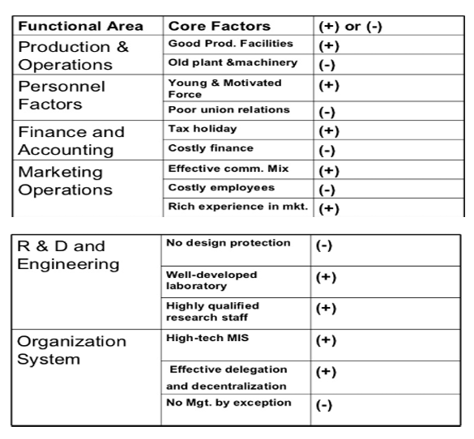
VALUE CHAIN ANALYSIS
A value chain is a set of activities that a firm operating in a specific industry performs in order to deliver a valuable product (i.e., good and/or service) for the market. The concept comes through business management and was first described by Michael Porter in his 1985 best-seller, Competitive Advantage: Creating and Sustaining Superior Performance.
Value chain analysis (VCA) is a process where a firm identifies its primary and support activities that add value to its final product and then analyze these activities to reduce costs or increase differentiation.
Porter's Value Chain Analysis.
Back in 1985, Michael Porter, a Harvard Business School professor, introduced a basic value chain model in his book Competitive Advantage. He identified several key steps common among all value chain analyses and determined that there are primary and supporting activities that when performed at the most optimal levels will create value for their customers, such that the value offered to the customer exceeds the cost of creating that value, resulting in higher profit. Porter’s framework groups activities into primary and support categories
The primary activities focus on taking the inputs, converting them into outputs, and delivering the output to the customer. The support activities play an auxiliary role in primary activities. When a company is efficient in combining these activities to provide a superior product or service, then the customer is willing to pay more for the product than the cost to make and deliver the product which results in a higher profit margin.

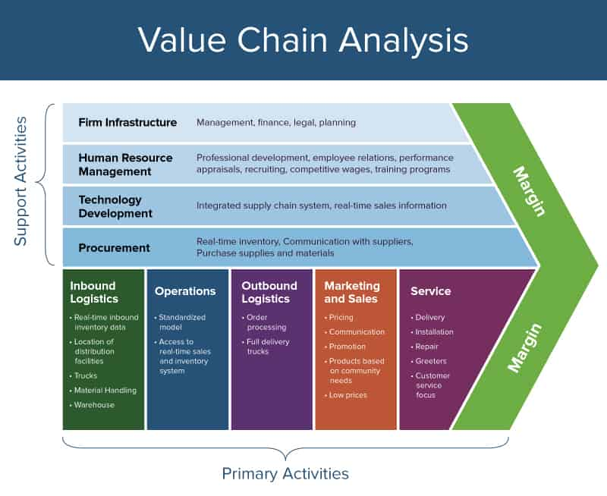
The firm’s primary activities include:
• Investment team (portfolio managers, analysts) – tasked with making the investment decisions.
• Operations and traders – tasked with ensuring the investments are in line with the guidelines set forth by the client, and the trades are at the best execution price.
• Marketing and sales – responsible for procuring clients.
• Service (client relationship management) – responsible for providing all the touch points to the client. Support activities include:
• Technology – designs a trading and client module that is efficient and effectively allows the team to provide the highest level of service and make the best investment decisions.
• Human Resources – finds and retains the highest level of talent at the firm.
- Infrastructure – includes the lawyers and risk managers whose oversight is crucial to ensuring the client’s guidelines are followed, the investment risk is controlled, and the firm is operating within the regulations established by the SEC.
SWOT ANALYSIS
SWOT ANALYSIS
SWOT analysis involves the collection and portrayal of information about internal and external factors which have, or may have, an impact on business.
MEANING OF SWOT:
• SWOT is a framework that allows managers to synthesize insights obtained from an internal analysis of the company’s strengths and weaknesses with those from an analysis of external opportunities and threats.
• SWOT is widely accepted tool due to its simplicity and value of focusing on the key issues which affect the firm.
• The aim of SWOT is to identify the strengths and weaknesses that are relevant in meeting opportunities and threats in particular situation.
HOW TO PERFORM THE ANALYSIS?
• SWOT can be done by one person or a group of members that are directly responsible for the situation assessment in the company.
• Basic SWOT analysis is done fairly easily and comprises of only few steps:
Step 1. Listing the firm’s key strengths and weaknesses.
Step 2. Identifying opportunities and threats
Strengths - Strengths are the qualities that enable us to accomplish the organization’s mission. These are the basis on which continued success can be made and continued/sustained.
Strengths can be either tangible or intangible. These are what you are well-versed in or what you have expertise in, the traits and qualities your employees possess (individually and as a team) and the distinct features that give your organization its consistency.
Strengths are the beneficial aspects of the organization or the capabilities of an organization, which includes human competencies, process capabilities, financial resources, products and services, customer goodwill and brand loyalty.
Examples of organizational strengths are huge financial resources, broad product line, no debt, committed employees, etc.
Weaknesses - Weaknesses are the qualities that prevent us from accomplishing our mission and achieving our full potential. These weaknesses deteriorate influences on the organizational success and growth. Weaknesses are the factors which do not meet the standards we feel they should meet.
Weaknesses in an organization may be depreciating machinery, insufficient research and development facilities, narrow product range, poor decision-making, etc. Weaknesses are controllable. They must be minimized and eliminated.
For instance - to overcome obsolete machinery, new machinery can be purchased. Other examples of organizational weaknesses are huge debts, high employee turnover, complex decision making process, narrow product range, large wastage of raw materials, etc.
Opportunities - Opportunities are presented by the environment within which our organization operates. These arise when an organization can take benefit of conditions in its environment to plan and execute strategies that enable it to become more profitable. Organizations can gain competitive advantage by making use of opportunities.
Organization should be careful and recognize the opportunities and grasp them whenever they arise. Selecting the targets that will best serve the clients while getting desired results is a difficult task.
Opportunities may arise from market, competition, industry/government and technology. Increasing demand for telecommunications accompanied by deregulation is a great opportunity for new firms to enter telecom sector and compete with existing firms for revenue.
Threats - Threats arise when conditions in external environment jeopardize the reliability and profitability of the organization’s business. They compound the vulnerability when they relate to the weaknesses.
Threats are uncontrollable. When a threat comes, the stability and survival can be at stake. Examples of threats are - unrest among employees; ever changing technology; increasing competition leading to excess capacity, price wars and reducing industry profits; etc.
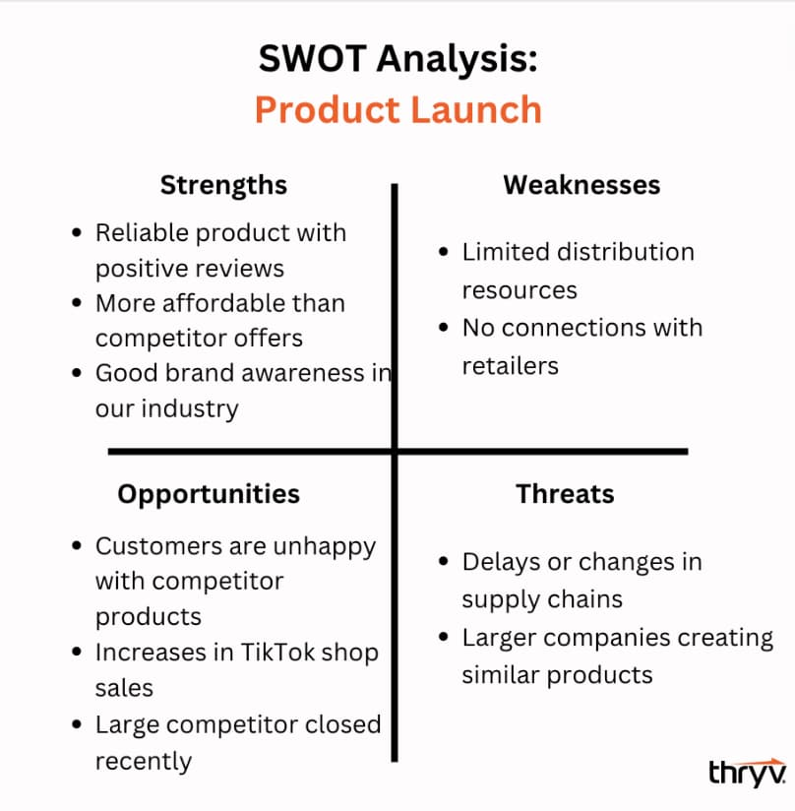
TOWS MATRIX:
• The TOWS Matrix is derived from the SWOT Analysis model, which stands for the internal Strengths and Weaknesses of an organization and the external Opportunities and Threats that the business is confronted with.
• The acronym TOWS is a variant of this and was developed by the American international business professor Heinz we rich.
• The TOWS Matrix is aimed at developing strategic options from an external-internal analysis and is a practical tool, particularly in the fields of business and the TOWS Matrix helps businesses to identify their strategic options.
Take note of the following specific elements of a TOWS matrix:
Strengths-Opportunities Strategies: SO strategies or maxi-maxi strategies involve the use of strengths to maximize strengths.
S-O STRATEGY– Develop plans that leverage the strengths of the company to capitalize on opportunities. A few ideas could be to diversify into new markets, improve the quality of products and reduce the costs of top-selling products.

Weaknesses-Opportunities Strategies: WO strategies or mini-maxi strategies involve minimizing weaknesses by taking advantage of opportunities,
W-O STRATEGY– After identifying weaknesses, focus on ways to resolve them in a goal to take advantage of opportunities. This might require finding new and cheaper suppliers, developing more aggressive marketing campaigns and reviewing operational processes to reduce costs.
How can partnerships with vocational education centers help the organization to improve itself and put more effort into customer acquisition? By presenting itself as an accredited apprenticeship provider, the organization will put itself on the market again and its shows that adapt to changing times and wants to offer different kinds of maintenance to businesses and housing co-operatives.
Strengths-Threats Strategies: ST strategies or maxi-mini strategies involve using strengths to minimize threats.
S-T STRATEGY– Use the company's strengths to counter external threats. If the company has a strong research and development department, for example, start new product development projects to enter different markets.
How can the organization use its skilled staff to compete with cheaper workers employed by competitors? A smart approach for the organization would be to communicate to the outside world that their staff has accredited diplomas and that it’s important for housing co-operatives to comply with legal requirements and safety standards
Weaknesses-Threats Strategies: WT strategies or mini-mini strategies involve minimizing weaknesses and avoiding threats.
W-T STRATEGY – Find ways to minimize weaknesses and counter threats. This could involve closing out poor-selling products, terminating under-performing employees and developing more aggressive selling techniques.
How can the organization better position itself in the market and thus reduce the threat posed by competitors? By presenting itself as an accredited apprenticeship provider, the organization can claim that they are a serious competitor and can possibly offer maintenance services by apprentices at reduced rates, with the work still being done by an accredited company.

Advantages of SWOT Analysis
SWOT Analysis is instrumental in strategy formulation and selection. It is a strong tool, but it involves a great subjective element.
SWOT Analysis helps in strategic planning in following manner-
- It is a source of information for strategic planning.
- Builds organization’s strengths.
- Reverse its weaknesses.
- Maximize its response to opportunities.
- Overcome organization’s threats.
- It helps in identifying core competencies of the firm.
- It helps in setting of objectives for strategic planning.
- It helps in knowing past, present and future so that by using past and current data, future plans can be chalked out.
SWOT Analysis provide information that helps in synchronizing the firm’s resources and capabilities with the competitive environment in which the firm operates.

Limitations of SWOT Analysis
SWOT Analysis is not free from its limitations. It may cause organizations to view circumstances as very simple because of which the organizations might overlook certain key strategic contact which may occur. Moreover, categorizing aspects as strengths, weaknesses, opportunities and threats might be very subjective as there is great degree of uncertainty in market.
There are certain limitations of SWOT Analysis which are not in control of management. These include-
- Price increase;
- Inputs/raw materials;
- Government legislation;
- Economic environment;
- Searching a new market for the product which is not having overseas market due to import restrictions; etc.
Internal limitations may include-
- Insufficient research and development facilities;
- Faulty products due to poor quality control;
- Poor industrial relations;
- Lack of skilled and efficient labour; etc

Michael Porter’s 5 forces Model
Porter’s 5 forces model is one of the most recognized framework for the analysis of business strategy. Porter, the guru of modern day business strategy, used the ethical frameworks derived from Industrial Organization (IO) economics to derive five forces which determine the competitive intensity and therefore attractiveness of a market. This theoretical framework, based on 5 forces, describes the attributes of an attractive industry and thus suggests when opportunities will be greater, and threats less, in these of industries.
Attractiveness in this context refers to the overall industry profitability and also reflects upon the profitability of the firm under analysis. An “unattractive” industry is one where the combination of forces acts to drive down overall profitability. A very un attractive industry would be one approaching “pure competition”, from the perspective of pure industrial economics theory .
These forces are defined as follows:
a) The threat of the entry of new competitors
b) The intensity of competitive rivalry
c) The threat of substitute products or services
d) The bargaining power of customers
e) The bargaining power of suppliers
The model of the Five Competitive Forces was developed by Michael E. Porter. Porters model is based on the insight that a corporate strategy should meet the opportunities and threats in the organizations external environment. Especially, competitive strategy should base on and understanding of industry structures and the way they change . Porter has identified five competitive forces that shape every industry and every market. These forces determine the intensity of competition and hence the profitability and attractiveness of an industry. The objective of corporate strategy should be to modify these competitive forces in a way that improves the position of the organization. Porters model supports analysis of the driving forces in an industry. Based on the information derived from the Five Forces Analysis, management can decide how to influence or to exploit particular characteristics of their industry.
The Five Competitive Forces are typically described as follows:
a) Bargaining Power of Suppliers The term suppliers comprises all sources for inputs that are needed in order to provide goods or services.
Supplier bargaining power is likely to be high when:
• The market is dominated by a few large suppliers rather than a fragmented source of supply
• There are no substitutes for the particular input
• The suppliers’ customers are fragmented, so their bargaining power is low
• The switching costs from one supplier to another are high
• There is the possibility of the supplier integrating forwards in order to obtain higher prices and margins this threat is especially high when
• The buying industry has a higher profitability than the supplying industry
• Forward integration provides economies of scale for the supplier
• The buying industry hinders the supplying industry in their development (e.g. reluctance to accept new releases of products)
• The Buying industry has low barriers to entry. In such situations, the buying industry often faces a high pressure on margins from their suppliers. The relationship to powerful suppliers can potentially reduce strategic options for the organization.
- Bargaining Power of Customers
Similarly, the bargaining power of customers determines how much customers can impose pressure on margins and volumes. Customers bargaining power is likely to be high when
• They buy large volumes; there is a concentration of buyers
• The supplying industry comprises a large number of small operators
• The supplying industry operates with high fixed costs
The product is undifferentiated and can be replaces by substitutes
• Switching to an alternative product is relatively simple and is not related to high costs
• Customers have low margins and are price sensitive • Customers could produce the product themselves
• The product is not of strategical importance for the customer
• The customer knows about the production costs of the product
• There is the possibility for the customer integrating backwards.
- Threat of New Entrants
The competition in an industry will be the higher, the easier it is for other companies to enter this industry. In such a situation, new entrants could change major determinants of the market environment (e.g. market shares, prices, customer loyalty) at any time. There is always a latent pressure for reaction and adjustment for existing players in this industry. The threat of new entries will depend on the extent to which there are barriers to entry.
These are typically
• Economies of scale (minimum size requirements for profitable operations),
• High initial investments and fixed costs
• Cost advantages of existing players due to experience curve effects of operation with fully depreciated assets
• Brand loyalty of customers
• Protected intellectual property like patents, licenses etc,
• Scarcity of important resources, e.g. qualified expert staff
• Access to raw materials is controlled by existing players ,Distribution channels are controlled by existing players
• Existing players have close customer relations, e.g. from long- term service contracts
• High switching costs for customers
• Legislation and government action
- Threat of Substitutes
A threat from substitutes exists if there are alternative products with lower prices of better performance parameters for the same purpose. They could potentially attract a significant proportion of market volume and hence reduce the potential sales volume for existing players. This category also relates to complementary products. Similarly to the threat of new entrants, the treat of substitutes is determined by factors like
• Brand loyalty of customers
• Close customer relationships
• Switching costs for customers
• The relative price for performance of substitutes
• Current trends.
- Competitive Rivalry between Existing Players
This force describes the intensity of competition between existing players (companies) in an industry. High competitive pressure results in pressure on prices, margins, and hence, on profitability for every single company in the industry. Competition between existing players is likely to be high when
• There are many players of about the same size
• Players have similar strategies
• There is not much differentiation between players and their products, hence, there is much price competition
• Low market growth rates (growth of a particular company is possible only at the expense of a competitor)
• Barriers for exit are high (e.g. expensive and highly specialized equipment)
Barriers to Entry and Exit
A barrier to entry is something that blocks or impedes the ability of a company (competitor) to enter an industry. A barrier to exit is something that blocks or impedes the ability of a company (competitor) to leave an industry.
In general, industries that are difficult for new competitors to enter may enjoy periods of good profitability and limited rivalry among competitors. Conversely, industries that are easy to enter attract new companies into the industry during periods of profitability. So, rivalry among competitors can be intense. On the other end, industries that are difficult to exit have more rivalry than industries that are easy to leave.
Some of the common barriers to entry and exit are listed below.
Typical Barriers to Entry
➢ Economies of size - The need for a large volume of production and sales to reach the cost level per unit of production for profitability is a barrier to entry.
➢ Capital intensive - A large capital investment per unit of output in facilities tends to limit industry entry.
➢ Intellectual property - Patents and other types of proprietary intellectual property are very effective in limiting industry entry.
➢ High switching costs - The tendency for buyers of an industry’s products to be reticent about switching to a new supplier tends to limit entry.
➢ Established brand identity - Industries dominated by branded products are difficult to enter due to the large amount of time and money required to create a competing branded product.
➢ Permitting requirements - Industries where permitting and licenses are required to establish production tend to have limited entry.
➢ Government standards - Industries where rigid industry standards exist tend to have limited entry.
Typical Barriers to Exit
➢ Investment in specialist equipment - Investments in specialized equipment that cannot readily be used in other industries tends to be an impediment to leaving the industry.
➢ Specialized skills - Highly specialized skills by industry participants that cannot be utilized in other industries tend to be an impediment to leaving the industry.
➢ High fixed costs - High levels of dedicated fixed costs tend to be an impediment to leaving an industry
If we combine entry and exit, we can predict industry rivalry, stability and profitability. An industry that is easy to enter but difficult to leave has intense industry rivalry and low profitability. At the first sign of excess profitability in the industry, competitors flock to the industry. However, when profitability falls, it is difficult to leave the industry so profitability remains low.
Examples
- Television industry
Established companies compete to produce better products and increase profitability.
- Athletic apparel industry
Nike faces competition from other brands, but there aren't many substitutes for athletic apparel.
- Urban mobility market
Xiaomi could enter the London market, but faces competition from other companies, and consumers have many options.
Other examples
- Walmart
Faces competition from traditional retailers and e-commerce giants like Amazon.
- Apple
Has a unique operating system and product, so its bargaining power of customers is low.
- Insurance
Buyers can bargain with insurers if there are many other companies offering the same service.
- Airlines
Customers have high bargaining power because they can easily compare prices online.

USING THE PORTER’S FIVE FORCE MODEL:
Step 1. GATHER THE INFORMATION ON EACH OF THE FIVE FORCES:
What managers should do during this step is to gather information about their industry and to check it against each of the factors (such as “number of competitors in the industry”) influencing the force.
¬ We have already identified the most important factors in the table below.
Step 2. ANALYZE THE RESULTS AND DISPLAY THEM ON A DIAGRAM:
After gathering all the information, you should analyze it and determine how each force is affecting an industry.
¬ For example, if there are many companies of equal size operating in the slow growth industry, it means that rivalry between existing companies is strong.
¬ Remember that five forces affect different industries differently so don’t use the same results of analysis for even similar industries!
Step 3. FORMULATE STRATEGIES BASED ON THE CONCLUSIONS:
At this stage, managers should formulate firm’s strategies using the results of the analysis
¬ For example, if it is hard to achieve economies of scale in the market, the company should pursue cost leadership strategy.
Product development strategy should be used if the current market growth is slow and the market is saturated
Competitive Advantage:
Competitive advantage refers to factors that allow a company to produce goods or services better or more cheaply than its rivals.
These factors allow the productive entity to generate more sales or superior margins compared to its market rivals.
Examples of competitive advantage:
- Access to natural resources not available to competitors
- Highly skilled labor
- Strong brand awareness
- Access to new or proprietary technology
- Price leadership

Building a Competitive Advantage
Michael Porter, the famous Harvard Business School professor, identified three strategies for establishing a competitive advantage: cost leadership, differentiation, and focus (which includes both cost focus and differentiation focus)
- Cost leadership
The goal of a cost leadership strategy is to become the lowest cost manufacturer or provider of a good or service. This is achieved by producing goods that are of standard quality for consumers, at a price that is lower and more competitive than other comparable product(s).
Firms employing this strategy will combine low profit margins per unit with large sales volumes to maximize profit. Companies will seek the best alternatives in manufacturing a good or offering a service and advertise this value proposition to make it impossible for competitors to replicate.
Example: Walmart.

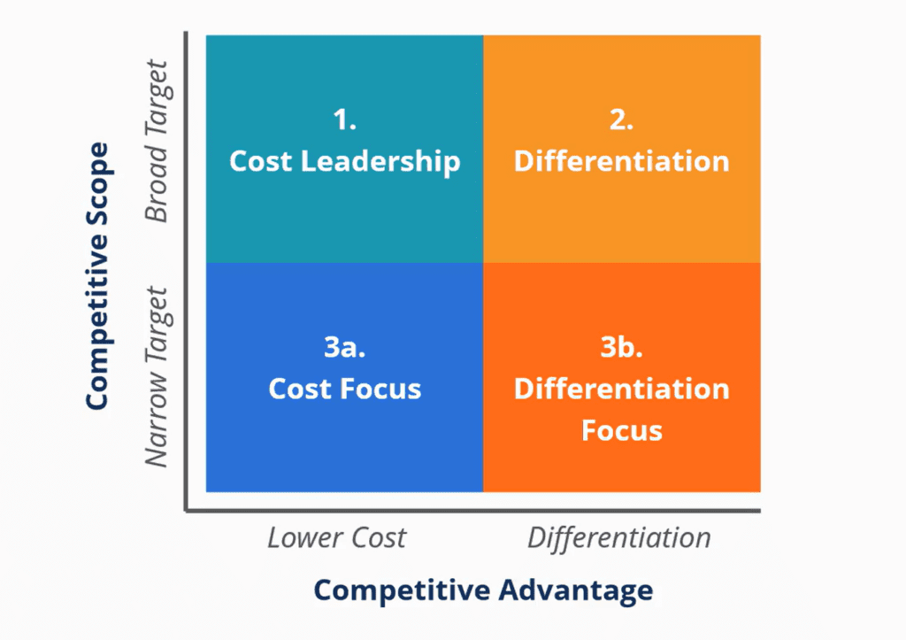
- Differentiation
A differentiation strategy is one that involves developing unique goods or services that are significantly different from competitors. Companies that employ this strategy must consistently invest in R&D to maintain or improve the key product or service features.
By offering a unique product with a totally unique value proposition, businesses can often convince consumers to pay a higher price which results in higher margins.
Example: Apple.

c. Focus
A focus strategy uses an approach to identifying the needs of a niche market and then developing products to align to the specific need area. The focus strategy has two variants:
- Cost focus: Lowest-cost producer in a concentrated market segment
- Differentiation focus: Customized or specific value-add products in a narrow-targeted market segment
Ex: A boutique hotel targeting luxury travelers

BCG Matrix
The Boston Consulting Group (BCG) growth share matrix is a planning tool that uses graphical representations of a company’s products and services to help the company decide what it should keep, invest more money in, or sell. The company’s offerings are plotted in a four-square matrix. The y axis represents the rate of market growth, and the x axis represents market share.
The BCG growth share matrix was introduced by the Boston Consulting Group in 1970.
According to this matrix, business could be classified as high or low according to their industry growth rate and relative market share.

Understanding the BCG Growth Share Matrix
The BCG growth share matrix breaks down products into four categories known as dogs, cash cows, stars, and question marks. Each category quadrant has its own set of unique characteristics.
Relative Market Share = SBU Sales this year leading competitors sales this year.
Market Growth Rate = Industry sales this year - Industry Sales last year.

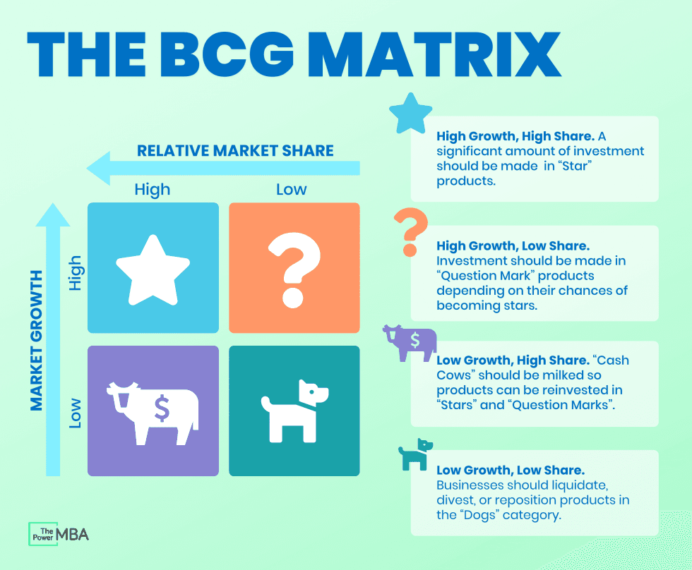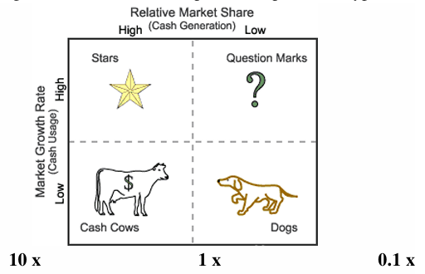

Stars:
Products that are in high-growth markets and that make up a sizable portion of that market are considered stars and should be invested in. Stars appear in the upper left quadrant. Stars generate high income but also consume large amounts of company cash. A star eventually becomes a cash cow when the market’s overall growth rate declines if it can remain a market leader.

Question Marks:
Questionable opportunities are those in high growth rate markets but in which the company doesn’t maintain a large market share. Question marks or problem children appear in the upper right portion of the grid.
Question marks typically grow fast but consume large amounts of company resources. Products in this quadrant should be analyzed frequently and closely to see if they’re worth maintaining.

Dogs:
A company is considered a dog and should be sold, liquidated, or repositioned if its product has a low market share and is at a low growth rate. Dogs are found in the lower right quadrant of the grid. Dogs don’t generate much cash for the company because they have a low market share and little to no growth. They can turn out to be cash traps, tying up company funds for long periods, so they’re prime candidates for divestiture

Cash Cows:
Products that are in low-growth areas but for which the company has a relatively large market share are considered cash cows. The company should milk the cash cow for as long as it can. Cash cows are seen in the lower left quadrant. They’re typically leading products in mature markets. These products often generate returns that are higher than the market’s growth rate. They sustain themselves from a cash flow perspective. These products should be taken advantage of for as long as possible.
The value of cash cows can be easily calculated because their cash flow patterns are highly predictable. Low-growth, high-share cash cows should be milked for cash to reinvest in high-growth, high-share stars with high future potential. When cash cows lose their appeal and move towards deterioration, then a retrenchment policy may be pursued.
Benefits of Using the BCG Matrix:
- Strategic Planning: Helps businesses make informed decisions about resource allocation and growth strategies.
- Portfolio Management: Provides a framework for evaluating and managing a company's product portfolio.
- Identifying Opportunities: Helps identify potential growth areas and areas for improvement.
- Simplifies Complex Decisions: Provides a visual and structured approach to strategic decision-making.

LIMITATIONS OF BCG MATRIX:
• The BCG Matrix produces a framework for allocating resources among different business units and makes it possible to compare many business units at a glance.But BCG Matrix is not free from limitations.
- BCG matrix classifies businesses as low and high, but generally businesses can be medium also. Thus, the true nature of business may not be reflected.
- Market is not clearly defined in this model.
- High market share does not always leads to high profits. There are high costs also involved with high market share.
- Growth rate and relative market share are not the only indicators of profitability. This model ignores and overlooks other indicators of profitability.
- At times, dogs may help other businesses in gaining competitive advantage. They can earn even more than cash cows sometimes.
- This four-celled approach is considered as to be too simplistic.
GE MODEL:
The GE / McKinsey matrix is a portfolio analysis matrix for business units developed in the 1970’s. It was developed by McKinsey & Company as part of a consulting assignment for General Electric . In practice, the addition "McKinsey" is almost always omitted and only referred to the General Electric Matrix.
DEFINITION:
• GE-McKinsey nine-box matrix- Is a strategy tool that offers a systematic approach for the multi business corporation to prioritize its investments among its business units?
• GE-McKinsey Is a framework that evaluates business portfolio, provides further strategic implications and helps to prioritize the investment needed for each business unit (BU).
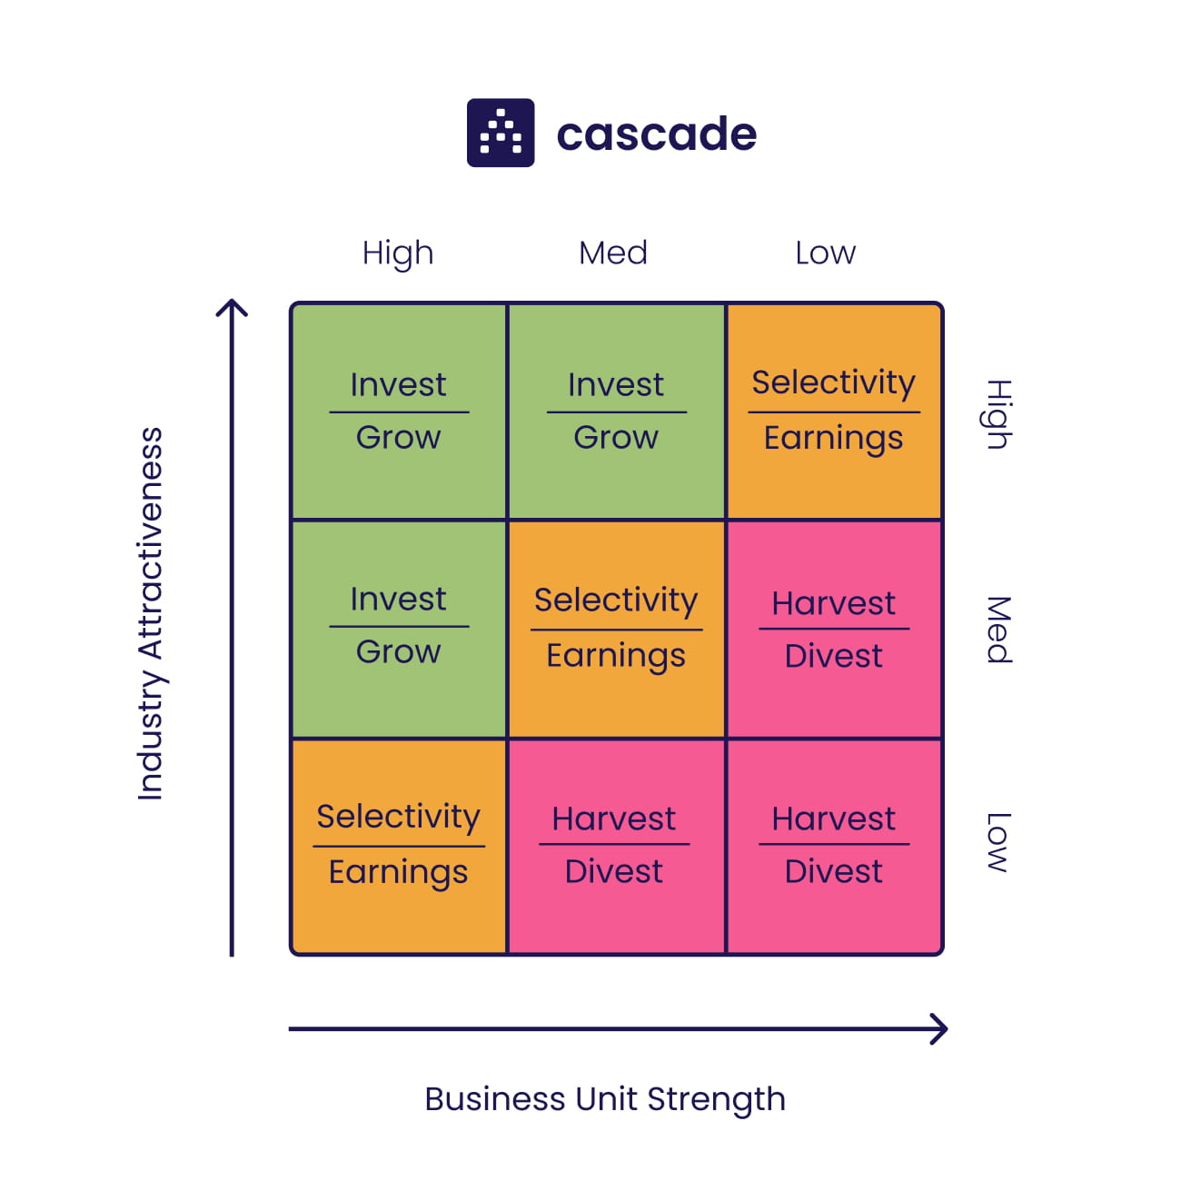

In 1970s, General Electric was managing a huge and complex portfolio of unrelated products and was unsatisfied about the returns from its investments in the products.
• At the time, companies usually relied on projections of future cash flows, future market growth or some other future projections to make investment decisions, which was an unreliable method to allocate the resources.
• Therefore, GE consulted the McKinsey & Company and as a result the nine-box framework was designed.
• The nine-box matrix plots the BUs on its 9 cells that indicate whether the company should invest in a product, harvest/divest it or do a further research on the product and invest in it if there’re still some resources left.
The BUs are evaluated on two axes:
¬ Industry attractiveness and
¬ A competitive strength of a unit
INDUSTRY ATTRACTIVENESS:
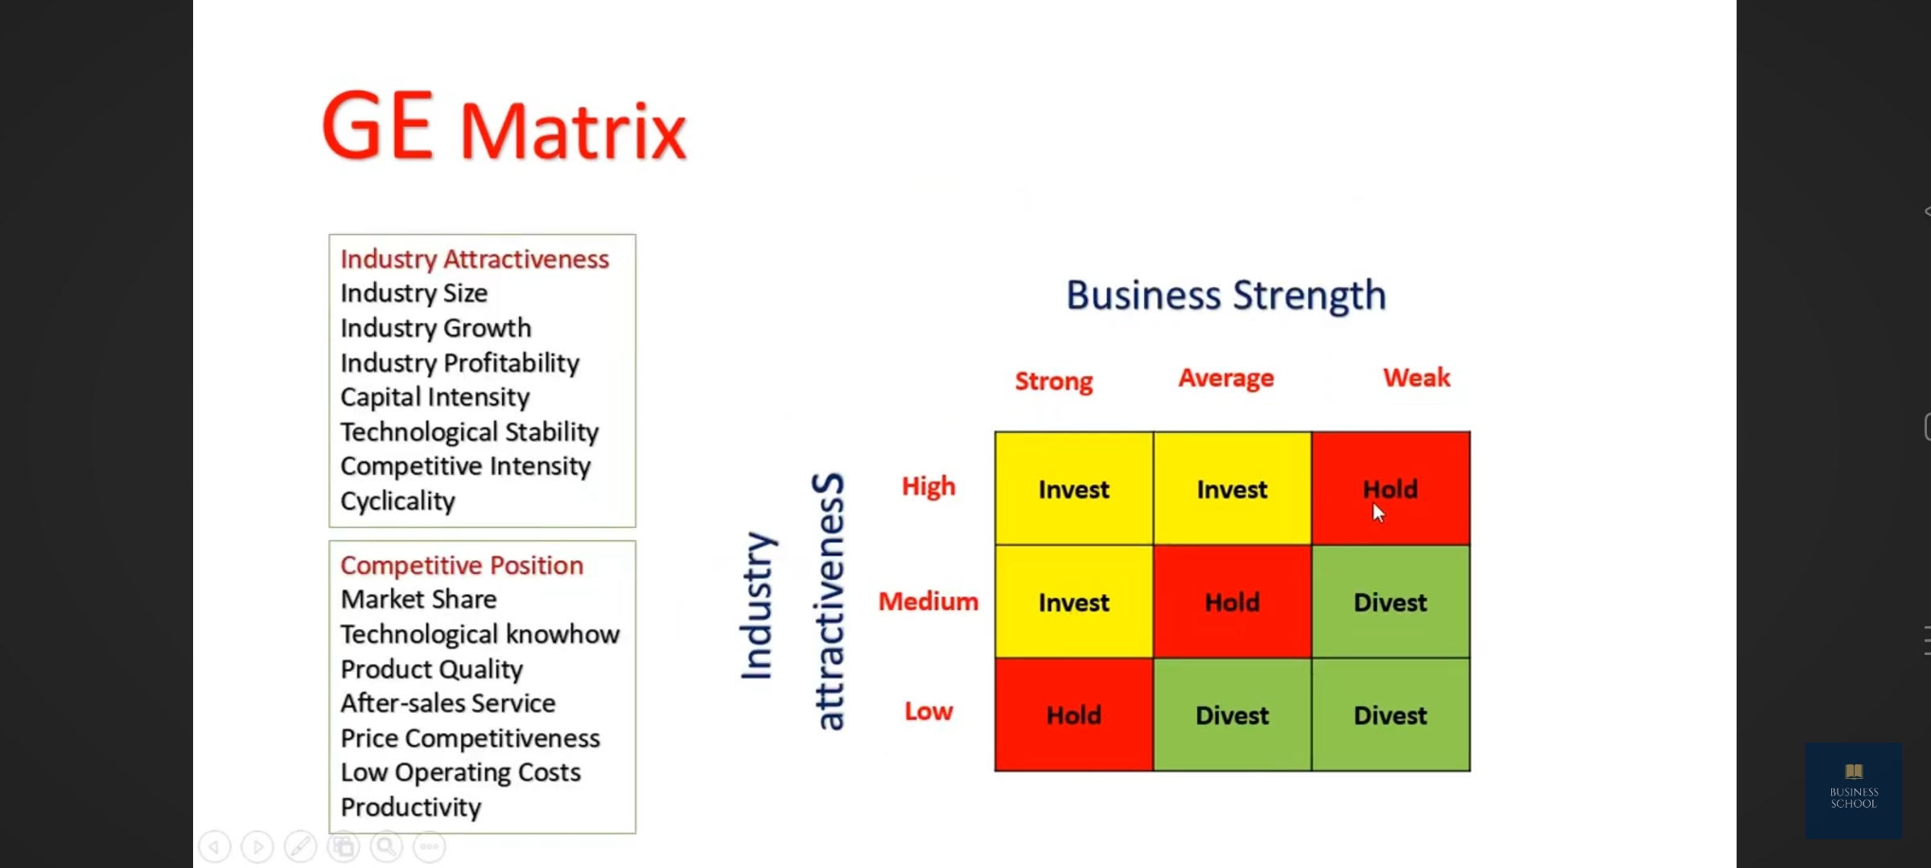

• Industry attractiveness indicates how hard or easy it will be for a company to compete in the market and earn profits.
• The more profitable the industry is the more attractive it becomes.
• When evaluating the industry attractiveness, analysts should look how an industry will change in the long run rather than in the near future, because the investments needed for the product usually require long lasting commitment.
• Industry attractiveness consists of many factors that collectively determine the competition level in it.
• There’s no definite list of which factors should be included to determine industry attractiveness, but the following are the most common:

COMPETITIVE STRENGTH/POSITION OF A BUSINESS UNIT OR A PRODUCT:
• Along the X axis, the matrix measures how strong, in terms of competition, a particular business unit is against its rivals.
• In other words, managers try to determine whether a business unit has a sustainable competitive advantage (or at least temporary competitive advantage) or not.
• If the company has a sustainable competitive advantage, the next question is: “For how long it will be sustained?”
INVEST/GROW BOX:
• Companies should invest into the business units that fall into these boxes as they promise the highest returns in the future.
• These business units will require a lot of cash because they’ll be operating in growing industries and will have to maintain or grow their market share.
• It is essential to provide as much resources as possible for BUs so there would be no constraints for them to grow.
• The investments should be provided for R&D, advertising, acquisitions and to increase the production capacity to meet the demand in the future.
SELECTIVITY/EARNINGS BOX:
• You should invest into this bus only if you have the money left over the investments in invest/grow business units group and if you believe that BUs will generate cash in the future.
• These business units are often considered last as there’s a lot of uncertainty with them.
• The general rule should be to invest in business units which operate in huge markets and there are not many dominant players in the market, so the investments would help to easily win larger market share.
HARVEST/DIVEST BOX:
• The business units that are operating in unattractive industries don’t have sustainable competitive advantages or are incapable of achieving it and are performing relatively poorly fall into harvest/divest boxes.

Advantages of GE Matrix
The advantages of GE McKinsey Matrix are:
- A simplified approach to portfolio analysis and investment allocation decisions
- Highly replicable and consistent framework
- Applicable across different industries
- An efficient method of determining strategic paths for multiple business units
- Helps measure and map the strategic position of business units
- Helps understand which businesses are making a profit and which aren't

Limitations of GE Matrix
The possible limitations of GE McKinsey Matrix are:
- The GE Matrix is only a snapshot of your portfolio's performance
- It relies on subjective estimations of market attractiveness and business strength
- Lacks nuance in differentiating between business units
- Teams may need to do more research before they can make investment decisions
- May not be suited for emerging or rapidly-evolving industries
ANSOFF MATRIX:
The Ansoff Matrix comes in - a simple yet highly effective strategy framework that has helped countless organizations successfully navigate the complexities of business growth for over half a century.
Developed by applied mathematician and business manager H. Igor Ansoff in 1957, the Ansoff Matrix (also known as the Product/Market Expansion Grid) provides a structured approach for evaluating different growth strategies based on whether they involve new or existing products and markets. By examining the four distinct quadrants of the matrix - Market Penetration, Market Development, Product Development, and Diversification - decision makers can gain valuable insights into the potential risks and rewards associated with each option, enabling them to make more informed choices and allocate resources effectively.

- Market Penetration: Focusing on increasing sales of existing products in existing markets.
- Market Development: Introducing existing products into new markets.
- Product Development: Developing new products for existing markets.
- Diversification: Creating new products for new markets.

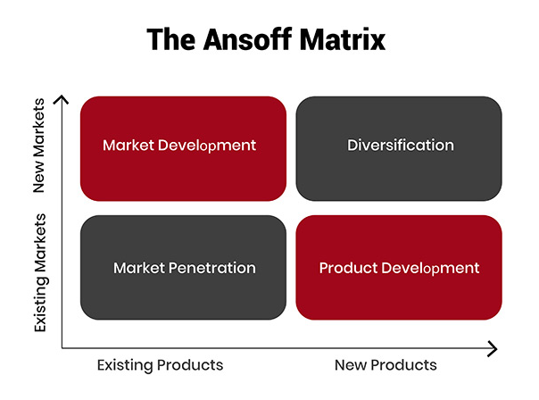

The Four Growth Strategies of the Ansoff Matrix:
Let's take a closer look at each quadrant and the key considerations for pursuing growth within these areas.

1. Market Penetration
The market penetration strategy focuses on increasing sales of existing products within existing markets. This approach is generally considered the least risky of the four options, as it leverages the company's established strengths and market knowledge. Typical tactics for achieving market penetration include:
- Increasing marketing and promotional efforts to attract new customers.
- Improving product quality or features to encourage repeat purchases.
- Adjusting pricing strategies to boost sales volume.
- Acquiring competitors to gain market share.
For example, a consumer packaged goods company seeking to increase its share of the snack food market might invest in targeted advertising campaigns, introduce new packaging designs, or offer promotional discounts to drive sales of its existing product lineup.
The primary advantage of the market penetration strategy is that it allows businesses to capitalize on their current assets and capabilities, minimizing the need for substantial investments in new product development or market exploration. However, the potential for growth may be limited, particularly in mature or saturated markets where competition is fierce and opportunities for differentiation are scarce.

2. Market Development
The market development strategy involves taking existing products into new markets, whether by targeting different customer segments, expanding into new geographic regions, or exploring alternative distribution channels. This approach enables companies to leverage their proven product offerings while tapping into fresh sources of demand. Common market development tactics include:
- Adapting products or marketing messages to appeal to new demographics.
- Establishing a presence in untapped geographic markets, either domestically or internationally.
- Partnering with new distributors or retailers to reach wider audiences.
- Developing online sales channels to complement brick-and-mortar operations.
A classic example of successful market development is Apple's expansion into the Chinese market, where the company's iconic iPhone and iPad products have found a massive new customer base.
While market development can open up significant growth opportunities, it also comes with its own set of risks and challenges. Entering new markets often requires substantial investments in market research, localization, and infrastructure development, and companies may face intense competition from established players or cultural barriers to adoption.

3. Product Development
Product development focuses on creating new products to serve your existing market. This strategy aims to leverage your brand's reputation and customer loyalty to introduce innovative offerings that address evolving customer needs or capitalize on emerging trends.
To implement a product development strategy, businesses should:
- Invest in research and development to identify opportunities for innovation and create products that align with customer needs.
- Gather customer feedback and insights to inform product design and features.
- Collaborate with key stakeholders, such as suppliers and distributors, to ensure successful product launches.
- Develop a strong value proposition and marketing strategy to generate interest and demand for the new product.
An example of product development is a Smartphone manufacturer introducing a new model with advanced features to appeal to its loyal customer base.

4. Diversification
Diversification is the riskiest of the four growth strategies, as it involves entering entirely new markets with new products. This strategy can be further divided into two types:
a. Related Diversification: Expanding into new markets or products that are related to your existing business, allowing for potential synergies in terms of resources, capabilities, or customer base. An example of related diversification is a car manufacturer expanding into the electric bicycle market, leveraging its expertise in vehicle design and manufacturing.
b. Unrelated Diversification: Venturing into markets or products that are unrelated to your current business, which can help mitigate risks associated with relying on a single market or product line. An example of unrelated diversification is a software company acquiring a chain of fitness centers to diversify its portfolio.
To pursue a diversification strategy, businesses should:
- Thoroughly assess the risks and potential returns associated with entering new markets or developing new products.
- Conduct extensive market research to validate the demand for the new product or service in the target market.
- Develop a clear understanding of the resources and capabilities required to successfully execute the diversification strategy.
- Create a robust plan for integrating the new business into the organization's overall structure and operations.
By carefully considering diversification opportunities through the lens of the Ansoff matrix, business leaders can make strategic decisions that drive growth while managing risk. The key is to find the right balance between leveraging existing strengths and exploring new opportunities in a way that aligns with the company's overall vision and goals.

Benefits of Using the Ansoff Matrix:
- Strategic clarity: By providing a clear framework for evaluating growth options, the Ansoff Matrix helps business leaders gain clarity on their strategic direction and prioritize initiatives based on their risk-return profile.
- Risk assessment: The matrix helps businesses understand the relative risks associated with each growth strategy, enabling them to make informed decisions and allocate resources appropriately.
- Structured decision-making: Using the Ansoff Matrix encourages a structured approach to decision-making, ensuring that all relevant factors are considered when evaluating growth opportunities.
- Alignment with business objectives: By aligning growth strategies with the overall business strategy and objectives, the Ansoff Matrix helps ensure that initiatives are focused and purposeful.
- Adaptability: The framework can be applied to various industries, business sizes, and market conditions, making it a versatile tool for any organization seeking growth.

Real-World Examples of Ansoff Matrix Application
Here are some real-world examples of Ansoff Matrix application:
- Market Penetration: Coca-Cola, the global beverage giant, has successfully employed market penetration strategies by increasing its advertising efforts, running promotional campaigns, and expanding its distribution network to reach more consumers within its existing markets.
- Market Development: Netflix, the streaming service provider, has pursued market development by expanding its services globally, entering new countries, and adapting its content offerings to suit local preferences.
- Product Development: Apple, the technology company, consistently engages in product development by introducing new products and services, such as the iPhone, iPad, and Apple Watch, to its existing customer base.
- Diversification: Amazon, the e-commerce and cloud computing company, has diversified its business by entering new markets and offering new products, such as Amazon Web Services (AWS) and Amazon Prime Video, which are distinct from its original online retail business.

Diversification:
A diversified company is a type of company that oversees several lines of business – most of them being unrelated to each other. Creating a diversified company is beneficial, as it provides several different product lines and customers, resulting in the company being shielded from any economic downswings or business fluctuations.
In strategic management, related diversification involves expanding into businesses with similarities to existing ones, leveraging shared resources and expertise, while unrelated diversification ventures into entirely new, unrelated industries, potentially spreading risk but also increasing complexity.
Here's a more detailed explanation:
Related Diversification:
Definition:
This strategy involves entering new industries or markets that have some connection or overlap with a company's existing businesses.
Examples:
  - A car manufacturer diversifying into electric vehicle technology.
  - A clothing retailer expanding into accessories.
  - A media company acquiring or merging with another media company.

Benefits:
  - Synergies: Leveraging existing strengths, resources, and expertise to create value in new areas.
  - Reduced Risk: By staying within familiar territory or related industries, the company can mitigate some of the risks associated with venturing into unfamiliar territory.
  - Enhanced Competitiveness: By leveraging existing strengths and capabilities, the company can gain a competitive advantage in the new industry.

Types of Related Diversification:
  - Concentric Diversification: Expanding into products or services that are closely related to the company's current offerings.
  - Horizontal Diversification: Expanding into products or services that are at the same stage of the value chain as the company's current offerings.
  - Vertical Diversification: Expanding into products or services that are upstream or downstream in the value chain.
Unrelated Diversification:
Definition:
This strategy involves entering industries or markets that have no apparent connection or overlap with a company's existing businesses.
Examples:
  - A media company diversifying into hospitality.
  - A pharmaceutical company diversifying into cosmetics.
  - A phone company diversifying into the television or radio business.

Benefits:
Risk Reduction: By diversifying into unrelated industries, the company can reduce its dependence on a single industry or market.
Opportunity for Growth: By exploring new markets and industries, the company can identify new growth opportunities.
Profitability: Diversifying into unrelated businesses can increase profitability by taking advantage of opportunities in different markets.

Challenges:
Complexity: Managing a portfolio of unrelated businesses can be challenging and lead to inefficiencies.
Lack of Synergies: It can be difficult to create synergies between unrelated businesses.
Higher Risk: Entering new industries with no prior experience can be risky.

Ex: Conglomerate diversification.

Strategic Groups:
A strategic group is a concept used in strategic management that groups companies within an industry that have similar business models or similar combinations of strategies

Characteristics of Strategic Groups
The following are the characteristics of Strategic Groups:
- Homogeneous within: Companies within a Strategic Group share similar strategic attributes.
- Heterogeneous between: Different Strategic Groups have distinct strategic attributes.
- Boundaries: There are boundaries between Strategic Groups, and it’s difficult for companies to move from one group to another.
- Stable: Strategic Groups are relatively stable over time, and changes occur gradually.

Importance of Strategic Groups
Strategic Groups are essential for understanding the competitive dynamics of an industry. The following are the importance of Strategic Groups:
- Competitive Analysis: Strategic Groups help us identify competitors that are similar to our company and understand their strategies. This analysis helps us identify potential competitive threats and opportunities.
- Strategy Formulation: Strategic Groups help us formulate effective strategies by providing insights into the different strategic approaches adopted by companies in the same industry.
- Industry Analysis: Strategic Groups provide a framework for industry analysis, helping us understand the competitive landscape and identify opportunities for growth and profitability.

Examples:
Food Service:
  - Fast-food chains: (e.g., McDonald's, Burger King, Subway) - known for low prices, quick service, and a wide variety of food options.
  - Fine-dining restaurants: (e.g., The French Laundry, Per Se) - known for high prices, elaborate service, and a focus on quality ingredients.
  - Cafes: (e.g., Starbucks, local coffee shops) - known for a relaxed atmosphere, coffee and light food options.
  - Family restaurants: (e.g., Olive Garden, Applebee's) - known for a casual atmosphere, family-friendly menu, and reasonable prices.

Automobile Industry:
  - Luxury car manufacturers: (e.g., BMW, Mercedes-Benz, Lexus) - known for high-end vehicles, premium features, and a focus on luxury.
  - Mass-market car manufacturers: (e.g., Toyota, Honda, Ford) - known for affordable, reliable vehicles, and a focus on practicality.
  - Sport car manufacturers: (e.g., Porsche, Ferrari, Lamborghini) - known for high-performance vehicles, and a focus on speed and luxury.

Technology Industry:
  - Cloud Computing Providers: (e.g., Amazon Web Services, Microsoft Azure, Google Cloud) - known for providing scalable and flexible computing resources.
  - Social Media Platforms: (e.g., Facebook, Instagram, Twitter) - known for connecting people and sharing information.
  - E-commerce Platforms: (e.g., Amazon, Alibaba) - known for online retail and connecting buyers and sellers.

Industry Life Cycle
The industry life cycle refers to the life cycle portraying different stages an industry experiences during its life. The four common phases are introduction, growth, maturity, and decline.
• Understanding the different stages of the life cycle help the businesses in making efficient decisions at each the businesses in making efficient decisions at each stage by identifying the opportunities and threat.
• Furthermore, it helps the businesses take entry, exit, or reentry strategies. It resembles an economic cycle, and similar to the stages of economic cycles, it is difficult to predict the duration of each stage.
Stages of Industry Life Cycle :
The industry life cycle model applies to most industries where businesses experience the four stages of the cycle. The entities enter the cycle when they develop an idea and then traverse the life cycle
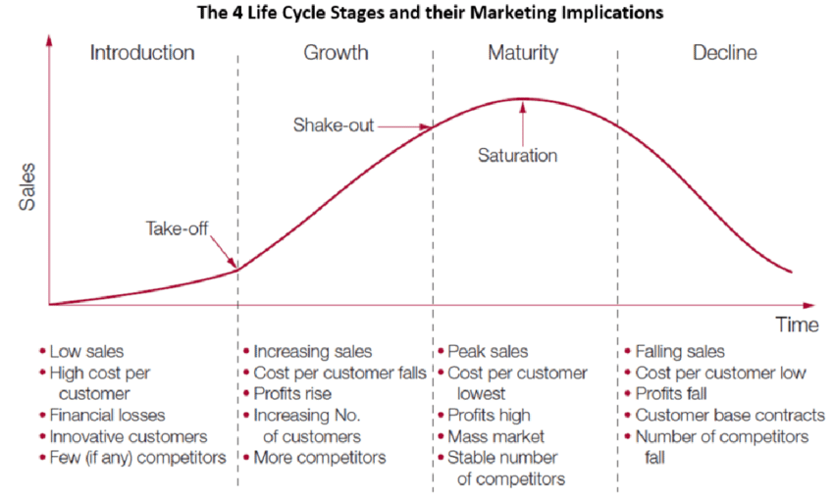
Introduction:
The introduction is the starting phase of the life cycle where a new product, service, idea, or solution to a persistent problem is introduced in the market.
• Since it is new to the market, the level of demand, sales, and revenue is low, potential consumers are not aware of it, the product may not be a complete version, and requires wide-reaching advertisements.
• Most of the aspects of the new industry will be in uncertain
• Most of the aspects of the new industry will be in uncertain categories like target market categories like target market and business model to follow to fit in the industry. and business model to follow to fit in
– Few innovators are creating the industry
– Competitors, substitute products , or complementary goods are less
– The industry works to reach out to as many people as possible
– Marketing and advertising are done aggressively to create awareness
– Discounts offers and rewards are given to the product to attract customers
The introduction, or startup, phase involves the development and early marketing of a new product or service.
• Innovators often create new businesses to enable the production and proliferation of the new offering. • Information on the products and industry participants are often limited, so demand tends to be unclear.
• Consumers of the goods and services need to learn
• Consumers of the goods and services need to learn more about them, while the new providers are still developing and honing the offering.
• The industry tends to be highly fragmented in this stage. Participants tend to be unprofitable because expenses are incurred to develop and market the offering while revenues are still low.
Growth:
Thesecond stage of the Industry life cycle is the growth phase. During the growth phase, consumers start to identify and show interest in the industry’s offerings.
• The supply and demand increase. Companies grow organically; they gain and increase market share .
• A dynamic environment is not uncommon for the industries during the growth stage. Also, the atmosphere is filled with opportunities, growth stage. Also, the atmosphere is filled with opportunities, pro activeness specifically in the strategy-making process, is crucial for pro activeness specifically in the strategy-making process, is crucial for growth. The companies in the industry now have appropriate business models and processes
.– Spend of research and development
– Producers try to optimize the existing offerings
– Focus on organic growth &geographical growth
– Complementary and supplementary goods emerge
– Investment increases
– Profit starts rising
Consumers in the new industry have come to understand the value of the new offering, and demand grows rapidly.
• A handful of important players usually become apparent, and they compete to establish a share of the newmarket.
• Immediate profits usually are not a top priority as companies spend on research and development or companies spend on research and development or marketing.
• Business processes are improved, and geographical expansion is common
• Once the new product has demonstrated viability, larger companies in adjacent industries tend to enter the market through acquisitions or internal development.
Maturity:
• The maturity phase follows the growth phase. The focus shifted from growth to increasing the cash flows .and revenue through the appropriate strategies
• They don’t have to spend on R&D or marketing, but competition is intense at this phase.
• To confront the competition, firms resort to strategies like mergers and acquisitions , economies of scale and acquisitions, economies of scale, cost reduction, competitive pricing, etc. , cost reduction, competitive
– The industry is leading and enjoys maximum profit
– Rate of growth slowdown representing the shakeout stage
– Intense competitive pressure and resources are constrained
– Dominant designs or improvisations occurs, adding more stress to compete– Competitively aggressive firms exhibit high performance
The maturity phase begins with a shakeout period, during which growth slows, focus shifts toward expense reduction, and consolidation occurs.
• Somefirms achieve economies of scale, hampering the sustainability of smaller competitors.
• As maturity is achieved, barriers to entry become higher, and the competitive landscape becomes more higher, and the competitive landscape becomes more clea
r. • Market share, cash flow, and profitability become the primary goals of the remaining companies now that growth is relatively less important.
• Price competition becomes much more relevant as product differentiation declines with consolidation.
Decline:
• After experiencing growth and maturity, the industry moves to a declining phase.
• At this phase, many companies in the industry face difficulty surviving or prolonging the successful period due to no growth and intense competition. Therefore, they have to find strategies apt for the phase to sustain. have to find strategies apt for the phase to sustain.
– The weaker competitors are forced out of the market
– May witness a steep fall in income
– The negative impact of factors like market competition, substitutes, consumer behavior, consumer psychology signifies
– The decline phase can be delayed using rebranding techniques, large-scale improvements, and attractive rewards
The decline phase marks the end of an industry's ability to support growth.
• Obsolescence and evolving end markets negatively impact demand, leading to declining revenues.
• This creates margin pressure, forcing weaker competitors out of the industry.
• Further consolidation is common as participants seek synergies and further gains from scale. synergies and further gains from scale.
• Decline often signals the end of viability for the incumbent business model , participants into adjacent markets. pushing industry
• The decline phase can be delayed with large-scale product improvements or repurposing, but these tend to prolong the same process.
Industry life cycle analysis:
• It is the process of evaluating the position of a company in the life cycle to understand its growth.
• The management and other stakeholders usually make decisions based on the company’s financial make decisions based on the company’s financial reports.
• At the same time, this analysis helps management to make the right strategic decisions based on the current stages where the company is in by understanding the industry

Strategic Control
“ It is the process by which managers monitor the ongoing activities of an organization and its members to evaluate whether activities are being performed efficiently and effectively and to take corrective action to improve performance if they are not” -Sam Walton
Types of strategic control:
- Premise Control: Premise control is necessary to identify the key assumptions, and keep track of any change in them so as to assess their impact on strategy and its implementation. Premise control serves the purpose of continually testing the assumptions to find out whether they are still valid or not. This enables the strategists to take corrective action at the right time rather than continuing with a strategy which is based on erroneous assumptions. The responsibility for premise control can be assigned to the corporate planning staff who can identify key assumptions and keep a regular check on their validity.
- Implementation Control: Implementation control may be put into practice through the identification and monitoring of strategic thrusts such as an assessment of the marketing success of a new product after pre-testing, or checking the feasibility of a diversification programme after making initial attempts at seeking technological collaboration.
- Strategic Surveillance: Strategic surveillance can be done through a broad-based, general monitoring on the basis of selected information sources to uncover events that are likely to affect the strategy of an organisation.
- Special Alert Control: Special alert control is based on trigger mechanism for rapid response and immediate reassessment of strategy in the light of sudden and unexpected events called crises. Crises are critical situations that occur unexpectedly and threaten the course of a strategy. Organisations that hope for the best and prepare for the worst are in a vantage position to handle any crisis.

Process of Strategic Control
Determine What to Control: The first step in the strategic control process is determining the major areas to control. Managers usually base their major controls on the organizational mission, goals and objectives developed during the planning process. Managers must make choices because it is expensive and virtually impossible to control every aspect of the organization’s
2. Set Control Standards: The second step in the strategic control process is establishing standards. A control standard is a target against which subsequent performance will be compared. Standards are the criteria that enable managers to evaluate future, current, or past actions. They are measured in a variety of ways, including physical, quantitative, and qualitative terms. Five aspects of the performance can be managed and controlled: quantity, quality, time cost, and behavior.
Standards reflect specific activities or behaviors that are necessary to achieve organizational goals. Goals are translated into performance standards by making them measurable. An organizational goal to increase market share, for example, may be translated into a top-management performance standard to increase market share by 10 percent within a twelve-month period. Helpful measures of strategic performance include: sales (total, and by division, product category, and region), sales growth, net profits, return on sales, assets, equity, and investment cost of sales, cash flow, market share, product quality, valued added, and employees productivity.
Quantification of the objective standard is sometimes difficult. For example, consider the goal of product leadership. An organization compares its product with those of competitors and determines the extent to which it pioneers in the introduction of base product and product improvements. Such standards may exist even though they are not formally and explicitly stated.
Setting the timing associated with the standards is also a problem for many organizations. It is not unusual for short-term objectives to be met at the expense of long-term objectives. Management must develop standards in all performance areas touched on by established organizational goals. The various forms standards are depend on what is being measured and on the managerial level responsible for taking corrective action.
3. Measure Performance: Once standards are determined, the next step is measuring performance. The actual performance must be compared to the standards. Many types of measurements taken for control purposes are based on some form of historical standard. These standards can be based on data derived from the PIMS (profit impact of market strategy) program, published information that is publicly available, ratings of product / service quality, innovation rates, and relative market shares standings.
Strategic control standards are based on the practice of competitive benchmarking – the process of measuring a firm’s performance against that of the top performance in its industry. The proliferation of computers tied into networks has made it possible for managers to obtain up-to-minute status reports on a variety of quantitative performance measures. Managers should be careful to observe and measure in accurately before taking corrective action.
4. Compare Performance to Standards: The comparing step determines the degree of variation between actual performance and standard. If the first two phases have been done well, the third phase of the controlling process – comparing performance with standards – should be straightforward. However, sometimes it is difficult to make the required comparisons (e.g., behavioral standards). Some deviations from the standard may be justified because of changes in environmental conditions, or other reasons.
5. Determine the Reasons for the Deviations: The fifth step of the strategic control process involves finding out: “why performance has deviated from the standards?” Causes of deviation can range from selected achieve organizational objectives. Particularly, the organization needs to ask if the deviations are due to internal shortcomings or external changes beyond the control of the organization. A general checklist such as following can be helpful:
- Are the standards appropriate for the stated objective and strategies?
- Are the objectives and corresponding still appropriate in light of the current environmental situation?
- Are the strategies for achieving the objectives still appropriate in light of the current environmental situation?
- Are the firm’s organizational structure, systems (e.g., information), and resource support adequate for successfully implementing the strategies and therefore achieving the objectives?
- Are the activities being executed appropriate for achieving standard?
6. Take Corrective Action: The final step in the strategic control process is determining the need for corrective action. Managers can choose among three courses of action: (1) they can do nothing (2) they can correct the actual performance (3) they can revise the standard.
When standards are not met, managers must carefully assess the reasons why and take corrective action. Moreover, the need to check standards periodically to ensure that the standards and the associated performance measures are still relevant for the future.
The final phase of controlling process occurs when managers must decide action to take to correct performance when deviations occur. Corrective action depends on the discovery of deviations and the ability to take necessary action. Often the real cause of deviation must be found before corrective action can be taken. Causes of deviations can range from unrealistic objectives to the wrong strategy being selected achieve organizational objectives. Each cause requires a different corrective action. Not all deviations from external environmental threats or opportunities have progressed to the point a particular outcome is likely, corrective action may be necessary.
Importance of Strategic Control
- Strategic Control is essential for any organization to succeed in the long run. It helps in:
- Monitoring and evaluating the performance of strategies
- Identifying potential problems and opportunities
- Taking corrective actions to maintain the strategic direction
- Ensuring that the organization adapts to changes in the environment
- Ensuring that the organization’s resources are used efficiently and effectively

Operational Control:
Operational control refers to the management and oversight of the day-to-day activities of an organization. It involves making sure that operations are running smoothly, efficiently and effectively.
This includes monitoring and adjusting processes, implementing policies and procedures, and ensuring compliance with regulations. It also includes managing resources and personnel, and making decisions that impact the overall performance of the organization.
Operational controls can be further broken down into three types:

Input controls:
Input controls ensure that the necessary resources are available to support the company’s activities. Examples of input controls include policies for hiring and training employees, guidelines for procurement, and procedures for managing inventory.

Process controls:
Process controls ensure that activities are performed efficiently and effectively. Examples of process controls include quality control procedures, productivity standards, and inventory management systems.

Output controls:
Output controls ensure that the results of the company’s activities are aligned with its strategic objectives. Examples of output controls include financial performance metrics, customer satisfaction surveys, and product/service quality assessments.

Process of Implementing Operational Controls
Implementing operational controls requires a deliberate process to ensure their effectiveness. The following steps can be followed to implement operational controls effectively:

Step 1: Identify the critical activities
Identify the critical activities that support the company’s strategic objectives. These activities are the ones that require the most attention and have the greatest impact on achieving the company’s strategic objectives.

Step 2: Establish performance metrics
Establish performance metrics for the critical activities identified in step 1. These metrics should be aligned with the company’s strategic objectives and should be measurable.

Step 3: Monitor performance
Monitor performance against the established performance metrics. This will provide insights into whether the company’s activities are aligned with its strategic objectives and whether adjustments are required.

Step 4: Take corrective action
Take corrective action as necessary to ensure that the company’s activities remain aligned with its strategic objectives.

Advantages of Operational Control
- Improved efficiency and productivity through better coordination of activities and resources.
- Increased flexibility in responding to changing conditions or unexpected events.
- Enhanced ability to monitor and control performance, including compliance with regulations and policies.
- Greater visibility into operations, allowing for better decision-making and strategic planning.
- Reduced risk of errors or accidents through improved oversight and monitoring.
- Enhanced customer service and satisfaction through more effective coordination of activities and resources.
- Increased transparency and accountability, which can improve organizational reputation and trust.
- Improved communication and collaboration among different departments and teams.
- Greater alignment of operations with overall organizational goals and objectives.
Disadvantages of Operational Control
- Increased bureaucratic procedures and paperwork, which can slow down decision-making and hinder innovation.
- Higher costs associated with implementing and maintaining control systems and processes.
- Increased micromanagement, which can stifle employee creativity and motivation.
- Difficulty in adjusting to rapidly changing conditions or unexpected events.
- Risk of over-reliance on control systems, leading to a lack of flexibility and adaptability.
- Risk of creating a rigid organizational culture that resists change and innovation.
- Decreased employee autonomy and empowerment, leading to lower morale and job satisfaction.
- Risk of creating a "control-oriented" rather than a "customer-oriented" organizational culture.
- Risk of creating a negative impact on the relationship between the management and employees.
- Difference between strategic control and operational control
Strategic Control | Operational Control
Long-term focus and goals | Short-term focus and specific tasks
Top-level management is responsible | Middle/lower-level management is responsible
Broad scope and strategic perspective | Narrow scope and operational perspective
Evaluates overall performance and progress towards long-term goals | Monitors day-to-day performance and progress towards specific tasks
Looks at external factors such as market trends and competition | Looks at internal factors such as resources and efficiency
Uses financial metrics such as return on investment and profitability | Uses operational metrics such as productivity and quality control
Involves making strategic decisions such as entering new markets or developing new products | Involves implementing decisions made at higher levels, such as how to manufacture a product efficiently
Example: Deciding to enter a new market or developing a new product | Example: Deciding how to manufacture a product efficiently or managing inventory levels

Strategy Formulation
Definition: Strategy Formulation is an analytical process of selection of the best suitable course of action to meet the organizational objectives and vision. It is one of the steps of the strategic management process. The strategic plan allows an organization to examine its resources, provides a financial plan and establishes the most appropriate action plan for increasing profits.
It is examined through SWOT analysis. SWOT is an acronym for strength, weakness, opportunity and threat. The strategic plan should be informed to all the employees so that they know the company’s objectives, mission and vision. It provides direction and focus to the employees.

Steps of Strategy Formulation:
The steps of strategy formulation include the following:
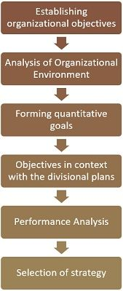
- Establishing Organizational Objectives: This involves establishing long-term goals of an organization. Strategic decisions can be taken once the organizational objectives are determined.
- Analysis of Organizational Environment: This involves SWOT analysis, meaning identifying the company’s strengths and weaknesses and keeping vigilance over competitors’ actions to understand opportunities and threats.
Strengths and weaknesses are internal factors which the company has control over. Opportunities and threats, on the other hand, are external factors over which the company has no control. A successful organization builds on its strengths, overcomes its weakness, identifies new opportunities and protects against external threats.
- Forming quantitative goals: Defining targets so as to meet the company’s short-term and long-term objectives. Example, 30% increase in revenue this year of a company.
- Objectives in context with divisional plans: This involves setting up targets for every department so that they work in coherence with the organization as a whole.
- Performance Analysis: This is done to estimate the degree of variation between the actual and the standard performance of an organization.
- Selection of Strategy: This is the final step of strategy formulation. It involves evaluation of the alternatives and selection of the best strategy amongst them to be the strategy of the organization.
Strategy formulation process is an integral part of strategic management, as it helps in framing effective strategies for the organization, to survive and grow in the dynamic business environment.

Levels of strategy formulation:
There are three levels of strategy formulation used in an organization:
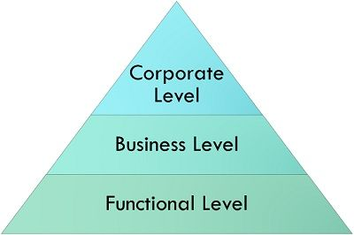
- Corporate level strategy: This level outlines what you want to achieve: growth, stability, acquisition or retrenchment. It focuses on what business you are going to enter the market.
- Business level strategy: This level answers the question of how you are going to compete. It plays a role in those organizations which have smaller units of business and each is considered as the strategic business unit (SBU).
- Functional level strategy: This level concentrates on how an organization is going to grow. It defines daily actions including allocation of resources to deliver corporate and business level strategies.

Importance of Strategy Formulation:
It is essential for the development of long-term direction and execution to maintain a successful running. The definition of a structured plan allows for a concentrated understanding of an organization's resources that will directly align with their strategic goals. This ensures that you can both weather market headwinds and also seize open field growth opportunities.
Provides Clear Direction
Strategy provides clear direction for the organization by setting some goals and defining a proper way to achieve them. Raising that level of clarity gets everyone through all levels of the organization pulling in one direction and allows efforts to be more focused and coordinated. A well- defined strategy serves as a blueprint that helps in decision-making and also directs efforts to be executed cohesively towards long term goals.
Better Resource Utilization
Creating a strategic plan allows an organization to allocate resources effectively, as it helps in easily identifying where funds need to be invested and focused. It helps organizations to direct its resources towards more fruitful opportunities which have higher growth potential and competitive advantage after identifying the internal strengths and weaknesses. In this way, resources get allocated to the right place and less resources are wasted giving cost-effective efficient results.
Enhances Competitive Positioning
Developing a game plan lets organizations to study the market and competitors, thus adjusting positioning accordingly. This allows organizations to know where the opportunities are as well as the threats, when we identify these then it would be possible for us to differentiate ourselves from competitors and grab a part of market share. Taking this proactive stance improves their competitive outlook and allows them a healthier market space.
Helps Adapt to Change
An effective strategy gives a structure for dealing with changes in the business landscape such as market trends or new inventions. That will obviously occur by refining and adjusting our strategies, to ensure the organization is dynamic enough to address everything that comes at it. This flexibility is what enables the organization to remain responsive and competitive in a rapidly changing environment.
Strategy Underpins Long-Term Success
A strong vision and strategic goals are the foundations of long term success, but how can an organization know what they should be doing without strategy? It allows organizations to think ahead and make informed decisions which are in sync with their objectives. By proactively focusing on strategic priorities and examining progress as no more than extended reality checks - a baseline for organizational continued growth, success in achieving those up-and-coming measures will be assured.
Stages of Strategy Formulation:
Strategy formulation stages provide a necessary set of steps that organizations must go through in order to establish effective strategies to achieve the goals and expectations into reality. These stages introduce a methodical logic that guides the processes of internal and external analyses, goal setting and definition of strategic approaches leading to concrete action steps. This is a guarantee that all strategies are effective and capable of delivering the expected results, as they have been informed adequately and developed in line with what we want to become.
Environmental Scanning
This is the initial stage under Strategy Formulation, in which an organization makes systematic scanning of the environment for collation, processing and dissemination of environmental information. This includes evaluating internal factors such as resources, capabilities and performance, along with external things like market trends, competition and economic conditions. The lessons learnt from here give a complete outlook on what the strategies in an organization would hinge upon.
Establishing Goals
After completing an environmental scanning, organizations move to developing specific goals that are possible given stacked insights This stage is designed to set clear, measurable and time bound objectives that are aligned with your organization's vision and mission. Each and every objective will guide your direction of focus; this means that all efforts, now strategic as well, are focused towards the end outcomes.
Strategy Formulation
It is defined as the stage when organizations develop detailed plans and strategies to be followed in accomplishing their objectives. It means drawing up concrete steps and plans based on its internal strengths, weaknesses as well as opportunities and threats. Formulating strategy is about aligning resources and capabilities to strategic goals. A way which makes end-to-end sense so that counting the final plan into operational steps has become a natural sequence of actions.
Strategy Implementation
Once strategies have been formulated, the process then moves to strategy implementation where plans are actually implemented throughout an organization. This includes setting responsibilities, resources and timelines for execution of the strategies. Coordination and communication are essential to get all the parts of an organization aligned and working towards those objectives.
Monitoring and Evaluation
The last stage of strategy formulation is the monitoring, evaluation to know how effectively implemented strategies are working. This includes monitoring key performance indicators, tracking goals being met (or not), and having the ability to adjust based on feedback from our audience / suspect we serve. Monitor and evaluate continuously so that strategies are up-to-date and relevant, enabling timely adjustments to stay on course with organizational goals.
Approaches to Strategy Formulation:
The steps in the process for strategy formulation are vital to help an organization develop good strategies that will work towards long-term goals of a company. As a model for effective management, these stages offer us with the necessary framework to carefully assess various internal and external elements helping you define your goals better while providing tentative yet actionable plans. In order to do so properly organizations need to know how it can be looked at in every step of the process making sure that the strategy they follow is informed by and follows their vision.
Environmental Scanning
It is the very first step of strategy formulation that indicates an organization to scan this environment in a systematic way and collect information about the internal & external factors. This also involves evaluating internal resources, competencies and performance along with investigating the external environment including market trends, competition as well as an economic scenario. The insights derived from this stage give a clear picture of the elements that will either aid or obstruct an organization's strategy.
Setting Objectives
After the environmental scan is conducted, organizations then develop SMART objectives that are grounded in what they have learned from the previous steps. This is the stage for setting clear, measurable objectives that are in sync with what your company stands for. Establishing goals aligns activity and efforts, so every strategic move works in favour of key results.
Strategy Formulation
In this stage, organizations plan for developing long term plans in advance to reach their goals. This includes developing practical, targeted activities and projects which build on the internal strengths, address weaknesses & vulnerabilities of an organization for realization of opportunities or mitigate threats. Careful thinking must go into strategy formulation about how you can line up your resources and capabilities against the set goals to come out with a unified plan of action.
Appropriate Implementation of Strategy
Once, the strategy is formed the next step is appropriate implementation across the entire organization for which proper plans should be put into action. This includes aligning the resources, authorities and timeline so that these strategies are employed well. Coordination and communication need to bind all the organizational levels together so that an implementation ensures there is consistency towards the strategic objectives.
Monitoring and Evaluation
The final stage of strategy formulation is monitoring and evaluation which evaluates how successful the strategies have been at implementation. It is monitoring performance metrics, reviewing with you how things are tracking against objectives and making changes as needed according to feedback received from changing conditions. Monitoring and evaluation also help to make sure that strategies stay relevant, benefitting from timely adjustments necessary if goals are still aligned with the organization.

Difference between Strategy Formulation and Strategy Implementation:
Formulating a strategy and implementing that Strategy are very important stages in strategic Management Process. In other words, formulation is about making long-term plans and defining goals while implementation refers to the process of carrying out these strategies resourcefully.
Aspect | Strategy Formulation | Strategy Implementation
Definition | The process of creating strategies and setting goals for the organization. | The process of executing the formulated strategies and achieving the set goals.
Focus | Emphasizes analyzing internal and external environments to develop strategic plans. | Emphasizes putting the formulated strategies into action through policies and procedures.
Activities | Includes conducting SWOT analysis, setting objectives, and developing plans. | Involves allocating resources, managing change, and executing plans.
Primary Concern | Determining what the organization should do to achieve competitive advantage. | Ensuring that the strategic plans are effectively executed and managed.
Decision-Making | Involves high-level decisions regarding goals, direction, and priorities. | Involves operational decisions related to resource allocation and h.
Time Horizon | Typically focuses on long-term goals and vision. | Focuses on short-term actions and their alignment with long-term objectives.
Role of Leadership | Leadership is responsible for guiding the vision and strategic direction. | Leadership is responsible for overseeing execution and adjusting plans as necessary.
Measurement of Success | Success is measured by the quality and relevance of the strategic plan. | Success is measured by the effectiveness of execution and achieving desired outcomes.

Strategy Implementation
According to Steiner :
"The implementation of policies strategies is concerned with the design. and management of systems to achieve the best integration of people, structures, processes, and resources, in reaching organisational purpose".

According to Mc Carthy :
"Strategy implementation may be said to consist of securing resources organizing these resource and directing the use of these resources within and outside the organisation".
According to Glueck :
"Strategic implementation is the assignment or reassignment of corporate and the employees SBU leaders to match the strategy. The leaders will communicate the strategy to Implementation also involves the development of functional policies about the organisation structure and climate to support the strategy and help achieve organisational objectives".
.
Nature of Strategy Implementation
- Dynamic and Ongoing Process: Strategy implementation is a dynamic and continuous process that demands a great deal of attention, capabilities of learning and adjustments.
- Comprehensive and Unified: Deploying a strategy is comprehensive, Multi-activity based across many parts of the organization.
- Resource-Intensive: Strategy execution is resource-intensive, because it requires a well of resources, time and money and people.
- Leadership and Communication Driven: Strong leadership and communication play a larger role in the successful implementation of strategies.
- Goal-Focused and Result-Oriented: Strategy implementation naturally is goal-focused, while the realization of results drives it.
Types of Strategy Implementation:
It is up to the goals and structure of an organization, strategy implementation can take various forms. These different types help the companies to choose which one is more suitable and the best way how they can execute their strategic plan.
Top-Down Implementation:
The top-down implementation refers to how the higher level management dictates a series of strategic objectives and tells those on the lower organization level what plans and processes to enact. Although this is an effective approach, it hinges upon strategic vision cascading trickling down to the entire organization through crisp communication from leadership. This is a governance method used by the senior leadership to maintain consistency and control, however it may struggle with buy-in from lower level employees.
Bottom-Up Implementation:
For ensuring this top-down approach, bottom-up implementation is preferred where strategic initiatives are generated by employees or middle management who understand the day-to-day operations of the business. By coaching employees, it gets staff invested in the changes and can prompt some excellent practical solutions. But implementing these strategies at the grassroot level, it is a tedious step where the belief lies, hence much coordination must be employed to see if it is aligned with organization at the top.
Integrated Implementation:
In the case of integrated implementation, strategic planning and execution is a combination of top-down & bottom-up natures, in which gain involvement from all levels of the organization. Its approach targets the balance of direction and engagement in leadership, which creates alignment and ownership of strategic goals. This can often lead to a faster more flexible execution but needs a lot stronger communication channels and alignment.
Modular Implementation:
An organization can roll out the strategic plan in modules based on its modular implementation, where it means that the strategic plan is broken into module components or subcomponents which can be deployed independently or incrementally. This enables organizations to adapt and adopt more difficult strategies a bit at a time, while making adjustments as they go along, based on feedback. It assists in the risk management and ensures that each model is consistent with the overall strategy but at same time it needs to be careful planning and integration of models will lead to achieve the end goal.
Project-Based Implementation:
Project-based: Here, focus is on executing strategies through specific projects or initiatives; each project (with goals, timelines, resources) comes with a strategy. This way, we are able to make concrete movements and supervise closely on each part of our overarching strategy. This can work very well in delivering clear outcomes (squads and chapters) but it also demands strong project management to make sure that all projects contribute towards the strategic vision.
Strategy Implementation Process:
The implementation of strategy is the systematic process through which a company creates results from its strategic plans. It goes through a number of crucial steps to guarantee that strategic goals are met or adjusted on a timely basis.
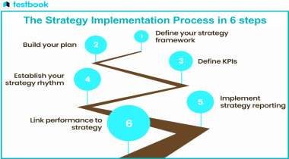
Setting Objectives and Key Performance Indicators (KPIs)
The main output of the first stage in the implementation of strategy is to establish clear objectives and key performance indicators (KPIs). Goals need to be specific, measurable, achievable, relevant and time-bound (SMART), whereas KPIs include measurable metrics used for monitoring the implementation success. This is done to align all efforts with the overall strategic objectives and provide meaningful follow-up & assessment.
Developing Action Plans
The action part is made up of detailed plans that break down the annual objectives and KPIs into specific tasks, timelines and responsibilities for achieving these targets. An action plan has to break the strategic goals over achievable tasks and who they are assigned to: whether each member of the team, or even department. Implementation roadmap- this step gives a seasoned plan to execute and ensure all the resources, efforts are well managed.
Allocating Resources
Proper resources, such as financial, human and technological assets should be invested in successful implementation. In the action planning stage, where you will need to budget and allocate your people wisely while arming them with the necessary tools and technology to execute on these action plans. Correct allocation of resources ensures that the project has enough steam and can cover any operational needs that arise during the project.
Communicating the Strategy
The strategy implementation process needs communication for all the members involved, so that they understand what are the strategic goals. This applies to top and middle management as well to lower level stakeholders. This involves shining a light on information that people should know through meetings and update reports amongst other media to keep everyone informed and engaged. If they are able to communicate clearly, it helps align efforts and reduces misunderstandings leading to a collaborative environment.
Monitoring and Evaluating Progress
The last part is where the progress of the Strategy being implemented can be iteratively monitored and evaluated against goals and KPIs set. The review of the previous execution cycle side by side with how it worked out along with any variances in between is meant to be a process through which required changes could be made. Periodical monitoring- this will keep the strategy on course, can foresee the need for modifications in time or adapt to any changes in the marketplace.
Importance of Strategy Implementation:
The importance of strategy implementation is that it helps to move strategic plans from the paper and the face to discussion to activities, turning vision into reality. Even the best of strategies fail to deliver without effective implementation.
Goals of the Organization
An effective strategy implementation leads to the fulfillment of organizational goals, translating strategic objectives into specific activities. Implementation drives progress toward key targets and desired outcomes by aligning all organizational efforts with the strategic plan. That kind of alignment is how you turn your strategic vision into action.
Resource Optimization
Applying a plan well saves resources; time, money and manpower. By planning and executing things strategically, the organization can get to know what needs more money investment as per requirement while also preventing wastage. This effectiveness not only makes the best possible use of each resource, but also allows future operations to proceed smoothly.
Better Coordination and Alignment
Implementation at an organizational level increases the coordination and alignment within the organization. It means that every division and team are all striving towards those strategic goals, which decreases conflict and increases synergy. Better coordination means better overall performance of the organization as a whole and implementation of strategic goals becomes more effective.
Facilitating Adaptation and Flexibility
An important thing that strategy implementation does is it helps facilitate adoption, flexibility. Ongoing monitoring and evaluation as programmes are rolled facilitate the revision of strategies in light of changing context or unexpected obstacles. It helps you stay relevant and successful in the long run.
Driving Accountability and Performance
Strategy execution promotes accountability by establishing who will execute key strategic activities in terms of clear roles and responsibilities. This helps in providing that level of clarity which, when you have it, allows performance to be measured against agreed upon objectives and holds individuals or teams responsible for what they each contribute. Increased transparency cultivates better accountability and with it a higher likelihood of top-down strategy accomplishment.
Challenges of Strategy Implementation:
The execution of strategic plans is difficult and the history of strategy implementation is littered with errors and failures. This is important to understand so that effective solutions can be developed and put in place to help realize your strategic goals.
Resistance to Change
Resistance to change is the big challenge in strategy implementation and it may come from employees or with some other stakeholders. Naturally people would resist changes to their routine and the consequent neglect reduces engagement, delaying execution. Dealing effectively with this resistance includes change management best practices, ranging from transparent communication to employee engagement.
Lack of Resources
Resources, and the time,money, personnel and who are also suffocating from lack of resources. However, no matter how good your strategies are there is always the possibility of failure, not because they were poorly designed but because with insufficient resources staff may have difficulty carrying them to completion or achieving goals. It would take impeccable planning and resource management to counter this worrisome trend and have the strategy backed by the firepower it craves for.
Lack of Communication
Good communication in strategy implementation is crucial, weak or lack of communication causes disagreements and differences. If those strategic goals and plans are not communicated well then the messages that tend to get filtered down through management may be vague and in this uncertainty employees won't know to which files their work belongs or what is the purpose of why they are doing it, causing them to not execute effectively. Being transparent and uniform when information is shared also helps with this problem.
Misalignment of Objectives
As an organization, the goals should be oriented in line with the overall strategy. Efforts can become fragmented and less effective when different parts of the organization are not working towards some clearly articulated goals. A departmental level ensures everyone in the organization is pulling for the same things and that every team is contributing to one or more of those objectives.
Poor Monitoring and Evaluation
If the monitoring and evaluation mechanisms are not enough it will lead to poor implementation of strategy as issues or detours with the plan would not be brought in a collective manner early enough. Organizations may lose visibility of problems or progress gaps if not assessed regularly. The creation of a solid monitoring & evaluation mechanism allows for real-time corrections to be made in the strategy.

Nature of Strategy Implementation:
The characters or scope of strategy implementation can be described as follows :

1) Action-Oriented :
Strategy implementation is action-oriented in the sense that it helps in materializing the things. The ability of management to bring about organisational changes is a part of it. It strives to attain enhancement operations and in business procedures on an ongoing basis. It progresses towards operational superiority. Strategy implementation helps in creating and nurturing culture which supports the strategy. It seeks to meet the performance objectives.
2) Require Leadership :
A proficient leadership is required for the implementation of a new strategy in order to persuade others in favor of it. It makes an effort to eliminate the probability of suspicion through motivation and encouragement. It can be regarded as the safe commitment of the parties involved. Harmony and zeal are established by skillful leadership only. It helps in organizing and coordinating all the parts of the implementation.
3) Employee Involvement :
The entire management group and official staff are included in implementation and execution of strategy. Just like every part of a clock has to perform in order to function smoothly, all the parts of an organisation have to unite and work, in order to ensure proper execution of strategy.
4) Varied Contexts :
Different environment required for every implementation situation, each of which is affected by varied business practices and competitive scenarios, working culture environment, incentives and compensations policies, blend of personnel and the history of the organisation, etc.

5) Challenging Management Job :
Implementing strategy can be regarded as a difficult management task because of the following reasons :
- Extensive range of challenging managerial activities which have to be executed.
- Several ways for dealing with every activity.
- Numerous problem causing issues which have to be sorted out.
- Calls for efficient management skills by experts.
- Need for introducing and managing a number of ideas all together.
- Difficulty in uniting the efforts of several teams in order to attain smooth functioning of the entire group as a whole.

Expansion Strategies :
Expansion strategies are the means by which companies seek to grow their business. Expansion can take many forms, including opening new stores or offices, entering new markets, acquiring new businesses, or diversifying into new product lines. Expansion strategies are often a key part of a company’s long-term growth plan, but they can also be risky and costly.

Types of Expansion Strategies
There are various types of expansion strategies, including:

Horizontal Expansion:
Horizontal expansion involves expanding the business within the same industry. It can take the form of increasing the company’s market share, expanding product lines, or entering new markets.

Vertical Expansion:
Vertical expansion involves moving up or down the supply chain by acquiring or merging with suppliers or distributors. This strategy can help to secure the supply chain, reduce costs, and improve efficiencies.

Concentric Expansion:
Concentric expansion involves entering related markets or industries. This strategy can help to leverage the company’s existing strengths and expertise while diversifying its revenue streams.

Conglomerate Expansion:
Conglomerate expansion involves entering unrelated markets or industries. This strategy can help to spread risk across different markets and industries, but it can also be risky and costly.

Advantages of Expansion Strategies
Expansion strategies can offer many advantages, including:
- Increased revenue and profitability
- Diversification of revenue streams
- Improved economies of scale
- Increased market share and brand recognition
- Access to new customers and markets
- Improved bargaining power with suppliers and customers

Risks of Expansion Strategies
Expansion strategies can also be risky and costly, including:
- Increased competition and market saturation
- Overextension of resources
- Failure to meet customer expectations
- Failure to integrate new acquisitions or businesses
- Difficulty in managing the complexities of different markets and industries
- Legal and regulatory challenges

Choosing the Right Expansion Strategy
Choosing the right expansion strategy depends on many factors, including:
- Company goals and objectives
- Available resources and capabilities
- Market conditions and trends
- Competitive landscape
- Regulatory and legal considerations
- Risk tolerance

Stability Strategy
Stability Strategy is a type of corporate-level strategy that focuses on maintaining the current market position of a business. This strategy is usually adopted by businesses that are satisfied with their current level of success and wish to continue operating in the same way.

Types of Stability Strategy
There are different types of stability strategies that businesses can adopt, including:
- No-change strategy: This strategy involves maintaining the status quo and continuing to do what the business has been doing without any significant changes.
- Pause/Proceed with Caution Strategy: This strategy involves taking a break from the current operations to assess the market and other internal factors that can affect the business. The business can then make necessary adjustments before proceeding with caution.
- Profit Strategy: This strategy focuses on improving the financial performance of a business by reducing costs and increasing revenue.

Implementing Stability Strategy
Implementing a stability strategy requires careful planning and execution. Here are some steps that businesses can follow:
- Assess the current situation: Conduct a thorough analysis of the internal and external factors that can affect the business, such as market trends, customer needs, and competitor behavior.
- Evaluate the current strategy: Review the current strategy to identify its strengths and weaknesses.
- Identify areas for improvement: Identify areas where the business can improve its operations and financial performance.
- Develop an action plan: Develop a plan to implement the necessary changes, including timelines, budget, and key performance indicators (KPIs).
- Monitor progress: Regularly monitor the progress of the implementation plan and adjust it as necessary.

Understanding Competitive Strategy Framework
The competitive strategy framework is a tool used by businesses to identify and analyze their competitors to develop effective business strategies. It involves four main steps:

Step 1: Identify Competitors
The first step is to identify your competitors. This involves understanding who your direct and indirect competitors are and their strengths and weaknesses.

Step 2: Analyze Competitors
The next step is to analyze your competitors. This involves identifying their strategies, resources, capabilities, and limitations. You can use tools such as SWOT analysis, Porter’s Five Forces analysis, and market research to analyze your competitors.

Step 3: Develop Competitive Strategies
Based on the analysis, you can develop competitive strategies that focus on your strengths and weaknesses and address the opportunities and threats in the market. You can use strategies such as cost leadership, differentiation, and focus to gain a competitive advantage.

Step 4: Implement Strategies and Monitor Performance
Once you have developed your strategies, you need to implement them and monitor their performance. This involves setting performance metrics, tracking progress, and making adjustments as needed.

Framework for Competitor Analysis
To formulate a competitive strategy framework, you need to analyze your competitors using the following steps:

Step 1: Identify Competitors
Start by identifying your direct and indirect competitors. Direct competitors are those who offer similar products or services to yours. Indirect competitors are those who offer alternative solutions to your target audience.

Step 2: Analyze Competitors
Once you have identified your competitors, you need to analyze them using various tools such as SWOT analysis, Porter’s Five Forces analysis, and market research. SWOT analysis helps you identify your competitors’ strengths, weaknesses, opportunities, and threats. Porter’s Five Forces analysis helps you understand the competitive forces in your industry, such as the threat of new entrants, bargaining power of suppliers, bargaining power of buyers, threat of substitutes, and competitive rivalry. Market research helps you gather information about your competitors’ customers, products, and pricing strategies.

Step 3: Develop Competitive Strategies
Based on your analysis, you can develop competitive strategies that focus on your strengths and weaknesses and address the opportunities and threats in the market. For example, if your analysis shows that your competitors are offering similar products at a lower price, you can develop a cost leadership strategy by reducing your production costs. If your analysis shows that your competitors are focusing on a specific niche, you can develop a focus strategy by targeting a different niche.

Step 4: Implement Strategies and Monitor Performance
Once you have developed your strategies, you need to implement them and monitor their performance. This involves setting performance metrics, tracking progress, and making adjustments as needed. You can use tools such as balanced scorecard and key performance indicators (KPIs) to monitor your performance.

